**DEPARTMENT OF COMPUTER SCIENCE**

**FACULTY OF SCIENCE**

**UNIVERSITY OF JAFFNA**

**Miss. J. Samantha Tharani**

**Mr. K. L. P. P. Liyanaarachchi**

**Mentors :**

# Table of Content

1.Executive summary ....................................................................................................1

2.Declaration of authorship...........................................................................................2

3.Contribution of each member....................................................................................3

4.Consent of the client and Letter of approval of the final software............................4

5.Comments from Supervisor........................................................................................5

6.Table of Content.........................................................................................................6

7.List of Figures..............................................................................................................10

8.List of Tables...............................................................................................................11

9.Introduction................................................................................................................12

9.1Purpose of the project.........................................................................................12

9.2Scope of the project.............................................................................................13

10.Overview of the document.......................................................................................14

11.Requirement Engineering.........................................................................................15

11.1Techniques used for requirements gathering....................................................15

11.2Functional requirements....................................................................................16

11.3Non-functional requirements.............................................................................17

11.4Domain requirements.........................................................................................18

11.5Challenges...........................................................................................................21

12.Software Design.........................................................................................................22

12.1Software Design..................................................................................................22

12.2Software design approach..................................................................................23

12.3Context diagram.................................................................................................25

12.4Interaction diagrams..........................................................................................26

12.5Structural diagrams............................................................................................26

12.6Behavioral diagrams...........................................................................................26

12.7Data model.........................................................................................................27

13.Data Dictionary.........................................................................................................31

14.Implementation........................................................................................................33

14.1Tools and Techniques, and justifications...........................................................33

15.Testing......................................................................................................................84

16.Discussions and Challenges......................................................................................85

16.1Future Work......................................................................................................85

17. Conclusion................................................................................................................86

18.References...............................................................................................................87

# Executive summary

On-line hotel reservation systems are increasing in importance and greatly facilitate cross border consumer activity. The Internet has enabled hotels to contract directly with a huge number of potential customers.

It has also revitalized the role of agents and lead to a new type of agent, the web agent or travel gate, selling a far wider range of accommodation on behalf of a far wider range of hotels. However, while on-line booking has increased the range of offers available, there are also some emerging worries due to examples of unfair commercial practices and lack of transparency related to such reservations.

This study, conducted by Civic Consulting, looks at both pre-contractual and contractual matters concerning on-line hotel reservation systems, examines relevant Community rules, identifies gaps and, where needed, discusses possible policy options.

# 2. Declaration of authorship

We declare that this dissertation is our own unaided work. We have not included any material or data from other authors or sources, which are not acknowledged and identified in the prescribed manner. We have read the section in the exam regulations on plagiarism and understand that such offenses may lead the Examinations Board to withhold or withdraw the award of Bachelor of Business Administration.

………………… …………………….

Date Signature

# 3. Contribution of each member

* 2015/SP/007: Miss. S. Anusa

Collected the data from supervisor. Divided the project into parts and assigned the works to the group members. Finished the backend and the UI of the poison part of the project (Poison details, Bee sting, Wasp sting, Hornet sting, Black widow spider). Created the whole user interface. Modified the whole UI. Checked the connection of the pages. Monitored others work. Modified some back-end coding.

* 2015/SP/040: Mr. R. M. S. P. Gunawardhana

Collect the requirements from client. Implement User interface

* 2015/SP/141: Mr. M. Sathurshan

Got the permission letter from HOD through mentor. Collect the requirement from client. Creating bolg to update the project progress. Design sample interface by using mokeup pencil tool. Update progress of project on LMS. Creating Admin login page. And written project final report.

* 2015/SP/096: Miss. W. A. D. D. Nimeshika

Got the appointment to meet the client. Collect the requirements from client. Implement Admin panel. Correct all the errors on our system. And help to update the project progress report to LMS , help to finish project final report. Get the approval letter from client for our final system.

* 2015/SP/280: Miss. W. G. A. B. Chandrasena

Collect the requirements from client. Implement User interface

# 4. Consent of the client and Letter of approval of the final software

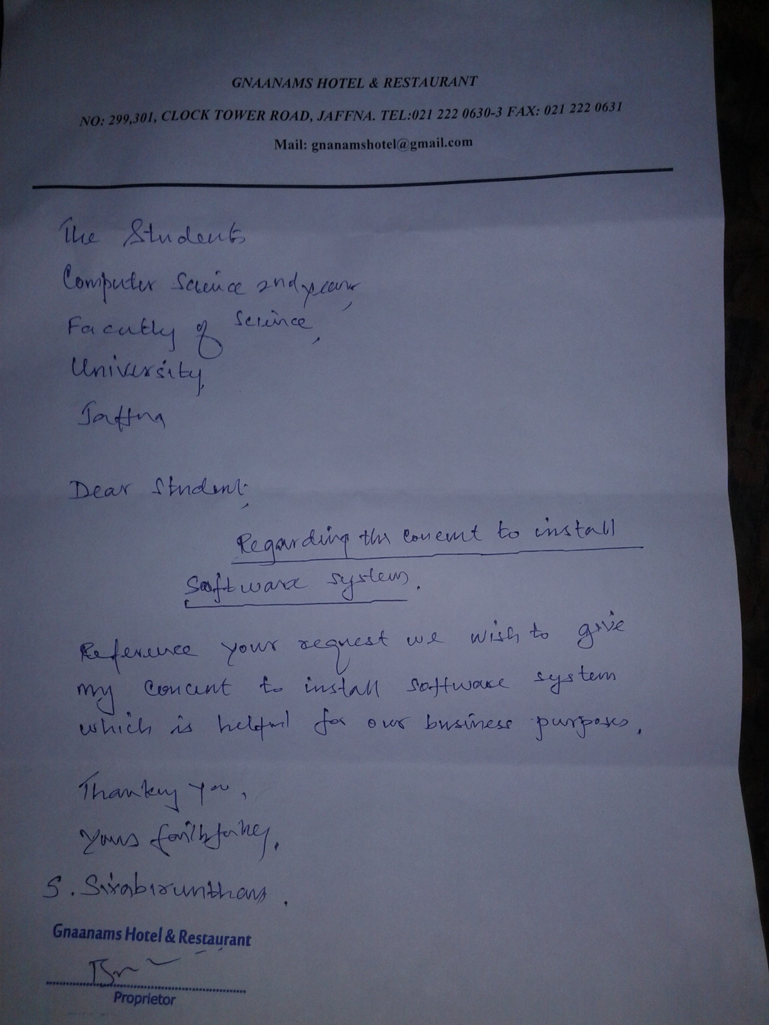

*figure 1: consent of client*

**5.Comments from Supervisor**

# 7.List of Figures

figure 1: consent of client...................................................................................................................4 figure 2: SDLC.................................................................................................................................19 figure 3: Context diagram................................................................................................................20 figure 4: Interaction diagrams..........................................................................................................21 figure 5: Structural diagrams............................................................................................................22 figure 6: Behavioral diagrams..........................................................................................................23 figure 7: ER diagram for Admin......................................................................................................25 figure 8: diagram for Executive.......................................................................................................25 figure 9: ER diagram for Customer..................................................................................................26 figure 10: Main Interface..................................................................................................................29 figure 11: Accommodation and facilities.........................................................................................31 figure 12: Reservation list form.......................................................................................................37 figure 13: Hotel Contact details.......................................................................................................46 figure 14: Admin login page.............................................................................................................49 figure 15: Admin..............................................................................................................................61

# 8.List of Tables

Index of Tables

Table 1: Index ...................................................................................................................................29

Table 2: User table ............................................................................................................................29

Table 3: Reservation table ................................................................................................................30

# 9. Introduction

## 9.1 Purpose of the project

The purpose of this project is to create a web acceesable program with a database for patients who have experienced poisinous bites or inhalation of poisinous substances in the Northern province. Hence, in times of need, it can be accessed or modified by the doctors using the web program to retrieve, update and maintain the information in the database to help serve better with;

* Efficient data management
* Accessible & Reliable method of tracking individual records
* Paperless environment
* Individual record management for both doctor and patient.
* Access to records are only allowed to authorized and registered Doctors.
* Confidentiality and privacy protected.

## 9.2 Scope of the project

The scope of this program is to manage the information flow between the patient and the doctor in an effcient and relaible manner. Futhermore, to organize effectively based on name, phone number, date of birth, address and previous medical history, while being securely stored with full confidentiality to manage all information, and to be accessed at any time from the server.

# 10. Overview of the document

The Electronic Medical Record system will provide service to record patient’s details and the types of poisoning in patients. The doctor can retrieve the patient’s details anytime.

# 11. Requirement Engineering

Requirement Engineering is the process of determining user expectations for a new or modified product. It involves frequent communication with system users. It is a process that involves all the activities required to create and maintain system requirements documentation. The essentials principles for requirement engineering activities are:-

* **Understand the problem**- User of EMRS may face some problems and they should be solved. This can be done by performing the data gathering techniques like questionnaire, interviews, observation, etc.
* **Modeling and analyzing the problem**- Structured analysis is used as the modeling technique which helps in analyzing the problems found in EMRS.
* **Requirement validation**- Requirement conflict, negotiations etc can be solved, because users of the EMRS may be of different background.
* **Requirement management**- In the early phases of requirement analysis, requirements continues to evolve software development phase. So there is a need to manage the changes as the problem evolves.
* **Communication problem**- The client of EMRS are required to

establish information between the client and the developer which is achieved through project specification, documentation and review meetings of the developer’s team.

## 11.1 Techniques used for requirements gathering

Requirement gathering in the particular project was mainly done through conducting discussions with the doctor in the Jaffna teaching hospital. Though most of the information was gathered by discussing with the doctor, the developing team conducted few discussions with the doctor to get a wide idea of the project. In this situation, they were enthusiastic and supported us by giving relevant information. Referring to previous records regarding our project was another way to gather requirements of our project. Formal system is well defined by the forms, reports, policy manuals and organization charts. Above mentioned tactic helped a lot in providing a clear view of the electronic medical record system. Majority we found the users of the system after discussions. It promotes the user roles of the system. Intention of building the system was clearly understood after this phase of software life cycle. Further analysis revealed where and when the system will be used.

After gathering and analyzing the client requirement it was expressed by a use case and the rest of the development process was built on it.

## 11.2 Functional requirements

The functional requirements of the Electronic Medical Record System are divided among the client and the administrator of the application. These functional requirements can be explained in detail as follows:

* **Use Case name: User Registration**
  + Description: This use case describes the scenario where the user registers with the application by providing all the necessary details.
  + Actor: User or the client (doctor)
  + Input: The user or the client will have to provide all the necessary details present in the patient’s registration form of the application.
  + Output: All the details entered in the patient’s registration page will be verified and accepted by the system into the database.
* **Use Case name: User Login**
  + Description: This use case describes the scenario where the doctor or the officer logs into the application, with the user-name and password he has provided while registering with the system.
  + Actor: User or the client (doctor)

➢

Input: The user or the client creates a user-name and password at the time of registering with the system. He then uses them to log on to the system and make reservations or view any information.

Output: The application then verifies the authenticity of the user-name and password that the client has provided and allows the user to view the information available on the system, if the user-name and password are valid.

* **Use Case name: Recording the details**
  + Description: This use case describes the scenario where the client records the patient’s details.
  + Actor: User or the client (doctor)
  + Input: After logging into the application, the client enters the patient’s details according to the type of poison
  + Output: The details will be recorded in the database.
* **Use case name: Retrieving the details**
  + Description: This use case describes the scenario where the client

retrieves the patient’s details.

* + Actor: User or the Client (doctor)
  + Input: After logging into the application, the client enters the patient’s ID number given by the hospital or the patient’s name.
* Output: The details will be retrieved and displayed to the client.

## 11.3 Non-functional requirements

• **Performance Requirements**

* All Web pages generated by the system shall be fully down-loadable inno more than 10 seconds.
* Responses to queries shall take no longer than 10 seconds to load onto thescreen after the user submits the query.

The system shall display confirmation messages to users within 4

seconds after the user submits information to the system

• **Security Requirements**

* Users shall be required to log in to the system for their own reservationinformation and modification with e-mail address and password.
* The system shall permit only authorized members who are on the list of authorized Menu Managers to do administrator’s task.

➢

The system shall permit customers to view only their own previously placed orders, not orders placed by other customers.

• **Software Quality Attributes**

* Availability: The system shall be available to users on the Internet 99.9% of thetime. And should be available to administrators all the time.

➢

Robustness: If the connection between the user and the system is broken prior to an order being either confirmed or canceled, the system shall enable the user to recover an incomplete reservation.

* Consistency: The availability of the rooms in system shall be updated when a transaction (more, administrator’s update operation) is finalized to ensure that the most updated information is delivery to any following queries from other customers. When administrator is updating the information, the consistency should also hold among user view.

## 11.4 Domain requirements

• **Use Case name: Login/Logout**

* Description: This use case describes the scenario where the administrator of the application, logs into the system and logs out after the work is done.
* Actor: Administrator

Input: The administrator of the website logs into the application with the username and password provided to him.

* Output: The application verifies the authenticity and displays the home page of the administrator.

• **Use Case name: Add/Delete or Modify Customer information**

* Description: This use case describes the scenario where the administrator adds, deletes or modifies customer information in the system database
* Actor: Administrator

➢

Input: The administrator of the applications logs onto the system with his username and password.

* Output: The application authenticates the administrator, and then displays the page where the administrator can add new customers to the database, or delete existing customers or modify details of customers in the database.

• **Use Case name: Cancellation of Reservations**

* Description: This use case describes the scenario where the administrator handles the cancellation of reservations by the customers.
* Actor: Administrator
* Input: The administrator logs onto the system with the given user-name and password.
* Output: The application authenticates the administrator and then displays the page where the administrator looks up the id of the customer who has requested cancellation of reservation. After canceling the reservation, the administrator then sends a confirmation e-mail to the customer.

• **Use Case name: E-mail confirmations**

* Description: This use case describes the scenario where the administrator sends e-mail confirmations to the customers of the application.
* Actor: Administrator

➢

Input: The administrator logs onto the application with the user-name and password provided.

Output: The application then authenticates the administrator and displays the page where the administrator can send e-mail confirmations to the customer. These email confirmations may be sent in cases where the customer has canceled a reservation or changed the personal information available on the website.

• **Use Case name: Add/Delete or Modify Hotel information**

➢

Description: This use case describes the scenario where the administrator adds, deletes or modifies hotel information in the database.

* Actor: Administrator
* Input: The administrator logs onto the system with the user-name and password provided to him.
* Output: The application authenticates the administrator, by verifying the username and password. Then the application displays the page where the administrator can add new facilities of the rooms and can update the cancellation policy and add new offers as well. He can even update the price per room in the hotel.

• **Use Case name: Image Management**

➢

Description: This use case describes the scenario where the administrator adds, deletes or modifies hotel images in the system drive.

* Actor: Administrator
* Input:The administrator logs onto the system with the user-name and password provided to him. Administrator choose image file from the Gallery in the system driveOutput: The application authenticates the administrator, by verifying the user name and password. Then the application displays Gallery folder in the drive where the administrator can choose images to add into the particular field

## 11.5 Challenges

**Lack of Prices Credibility:**

This is one of the biggest problems facing reservation for Gnanams’ hotel is changing their prices from day to day depending on their availability and without any prior notice, leading to the client's surprise that reservation companies' prices are much higher than hotels' and some times are less, not considering the different and intervening seasons.

**Lack of Availability Credibility:**

It is the second obstacle in my view ;this hotel is requesting bookings from hotels which in turn reply with no availability, only to discover moments later that the client had contacted the hotel directly and his request has been confirmed thus end up with the hotel selling the client directly.

**Poor Communication between the Reservation Department and other departments in the Hotel:**

This is the third obstacle which sometimes leads client to accusing the reservation company of cheating on him, all because he reached the hotel but didn't find a booking for him there although the company had sent a fax requesting reservation and received a reply confirming this reservation.

What happened is that the reservation department in the hotel didn't inform the reception department of this booking, or the reception didn't know that this reservation company is a hotel's client.

# 12. Software Design

## 12.1 Software Design

Project was designed using an object oriented approach. While developing the system we had to come across several diagrams in order to achieve the quality of the software product.

After creating the ER diagram it was mapped to a relational schema and normalized.

Finally the database was created.

## 12.2 Software design approach

As per the project management there should be a proper selection of the methodology so on that contrast we have to select the methodology for our project i.e. Electronic Management Record System. The method being used in developing the system is the System Development Life Cycle (SDLC). The SDLC process includes project identification and selection, project introduction and planning, analysis, design, implementation and maintenance. Structure of a methodology:-

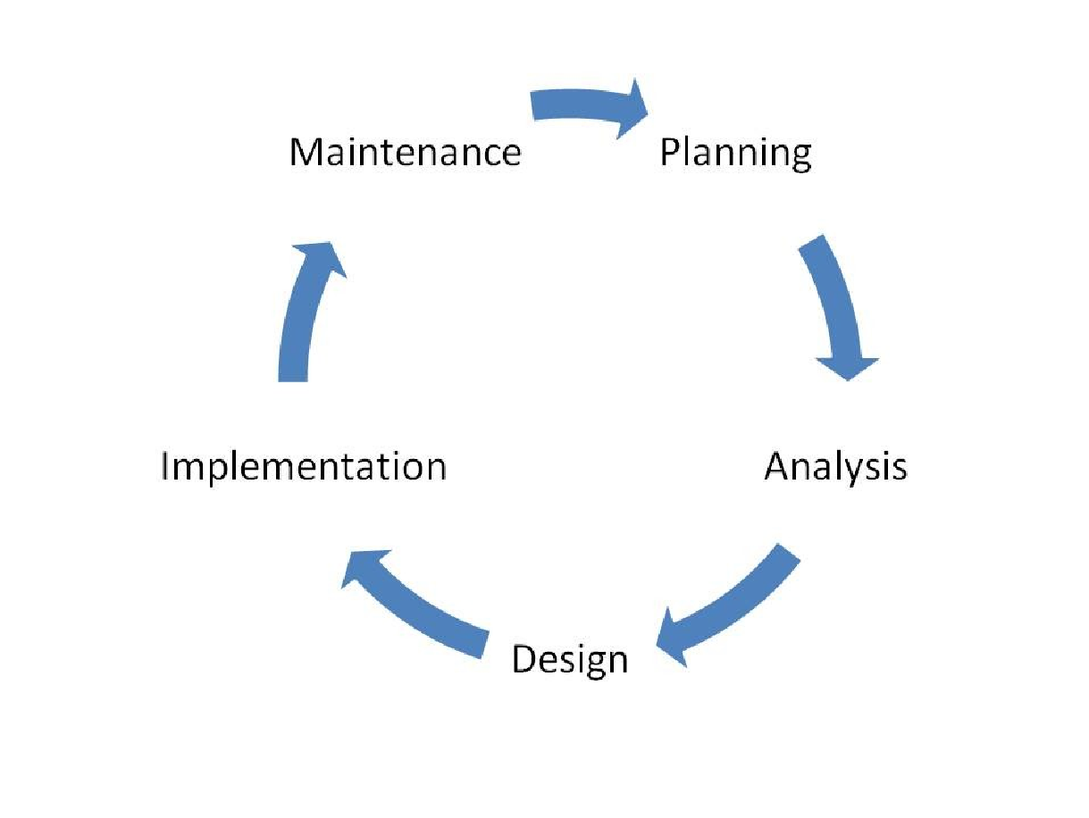

*figure 2: SDLC*

Each phase produces deliverables required by the next phase in the life cycle. Some phases are also inter-related with other phase. Planning is done in the first and analysis of the system is continued after that. Analysis of the system is being translated into design. Code is produced during implementation that is driven by the design. Testing verifies the deliverable of the implementation phase.

## 12.3 Context diagram

Context diagram is a top-level view of the information system.

Context diagram has one process symbol representing the entire information system.

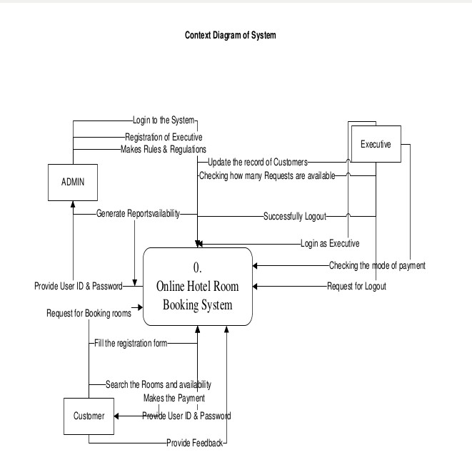

*figure 3: Context diagram*

## 12.4 Interaction diagrams

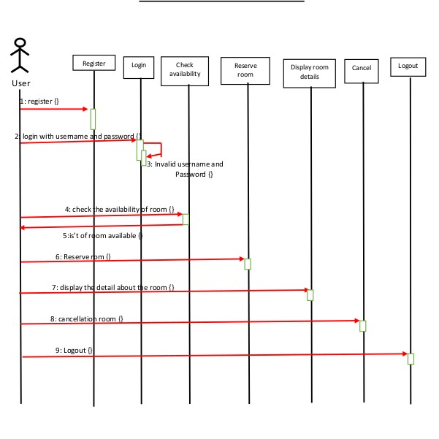

*figure 4: Interaction diagrams*

**12.5**

**Structural diagrams**

*figure*

*5*

*:*

*Structural diagrams*

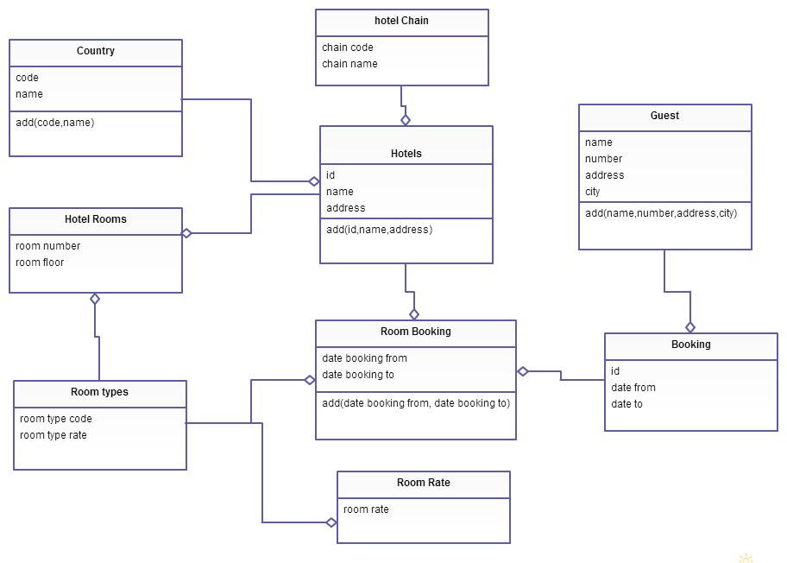

**12.6**

**Behavioral diagrams**

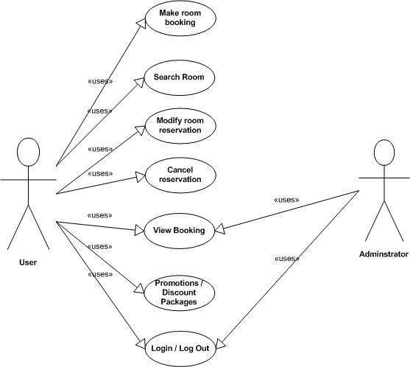

*figure*

*6*

*:*

*Behavioral diagrams*

## 12.7 Data model

**Entity Relationship Diagram**

There are basically 4 things which we consider while making ERD.

**ENTITY**

An entity is something, real or abstract, about which we store information. For our system there are basically these three entities:

1. Admin /Executive
2. Customer

**RELATIONSHIP**

A relationship is an association that exists among entities. For our system we have following relationships among 3 specified entities:

* One Admin can register many Executive (0:N)
* One Admin can add many Rooms (0:N)
* One Admin can view many Reports of Executive, Customer & Rooms (0:N)
* One Admin can delete many Executive (0:N)
* One Admin can edit information of many Executive (0:N)
* One Executive can check payment of Customer(1:N)
* One Executive can view many Reports of Rooms (1:N)
* One Executive can edit information of many booked Rooms (1:N)
* One Customer can search many rooms (2:N)
* One Customer can book many rooms (2:N)

***ATTRIBUTES***

Attributes is a property of an entity or a relationship type. *For our system we have following attributes of 3 specified entities:*

**Customer**- Id of Customer, Name of Customer, Room Type, No. of Room booked,

Checkin date, Check-out date and payment

**Admin/Executive** - Username and password.

**Room**- Room no, Room type, No of rooms, room status, room price.

* + **ER diagram for Admin**

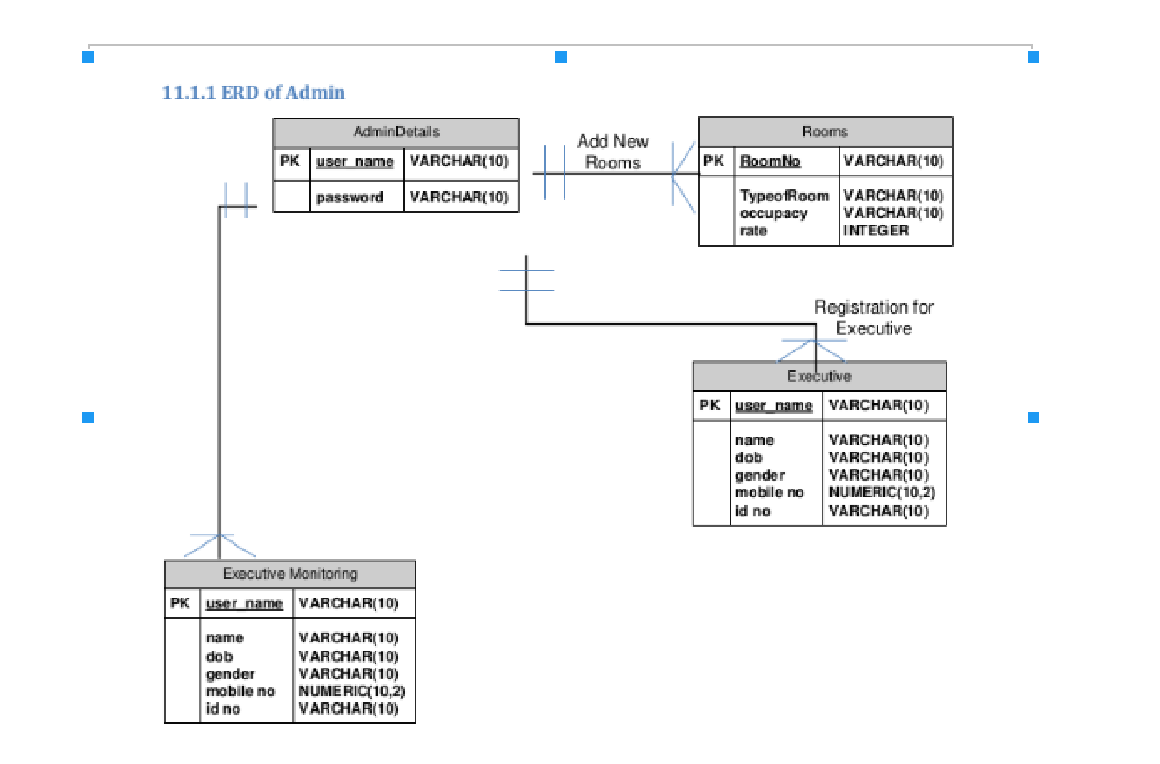

*figure 7: ER diagram for Admin*

* + **diagram for Executive**

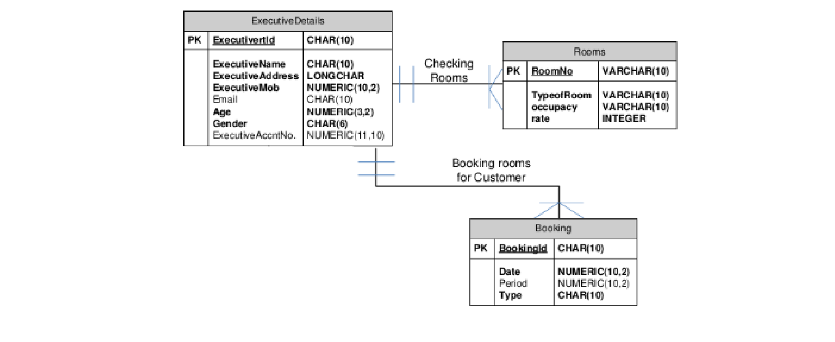

*figure 8: diagram for Executive*

* + **ER diagram for Customer**

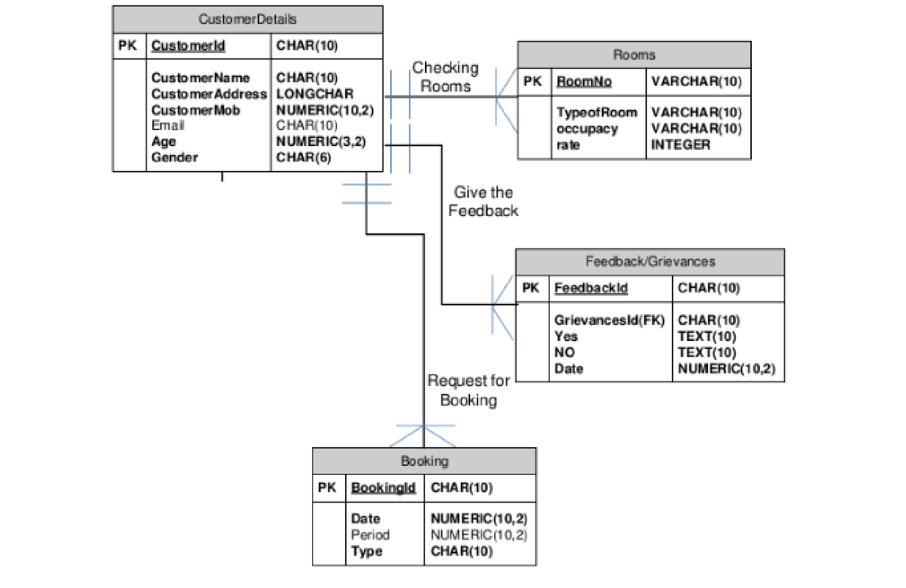

*figure 9: ER diagram for Customer*

**13. Data Dictionary**

Index

|  |  |  |  |  |  |  |  |  |
| --- | --- | --- | --- | --- | --- | --- | --- | --- |
| Key name | Typed | Unique | Packed | Column | Cardinalit y | Collation | Null | Comment |
| PRIMAR Y | BTREE | Yes | No | rsrv_id | 7 | A | No |  |
| rsrv_name | BTREE | Yes | No | rsrv_name | 7 | A | No |  |

*Table 1: Index*

User

|  |  |  |  |  |
| --- | --- | --- | --- | --- |
| No | Field_Name | DataType | Constraint | Description |
| 1 | User_id(primary) | int(8) | Primary key | It store Registration id |
| 2 | User_name | varchar(10) | Not Null | It store Customer Name |
| 3 | User_pw | varchar(10) | Not Null | It store Customer password |
| 4 | User_fail | varchar(10) | Null |  |
| 5 | User_role | varchar(10) | Not Null |  |

*Table 2: User table*

Reservation

|  |  |  |  |  |
| --- | --- | --- | --- | --- |
| No | Field_Name | DataType | Constraint | Description |
| 1 | rsrv_id(primary) | int(10) | Not null | It store reserve id |
| 2 | rsrv_timestamp | timestamp | Not null |  |
| 3 | rsrv_first_name | varchar(20) | Not null | It store Customer first Name |
| 4 | rsrv_last_name | varchar(20) | Not null | It store Customer last Name |
| 5 | rsrv_email | varchar(20) | Null | It store Customer mail |
| 6 | rsrv_contact | varchar(20) | Not null | It store Customer contact |
| 7 | rsrv_room | text | Not null | It store reserve room |
| 8 | rsrv_bed | int(10) | Null | It store reserve bed |
| 9 | rsrv_pillow | int(10) | Null | It store reserve pillow |
| 10 | rsrv_towel | int(10) | Null | It store reserve towel |
| 11 | rsrv_kit | int(10) | Null | It store reserve kit |
| 12 | rsrv_start | date | Not null | It store reserve start date |
| 13 | rsrv_end | date | Not null | It store reserve end date |
| 14 | rsrv_guest | varchar(5) | Not null | It store reserve guest |
| 15 | rsrv_notes | text | Not null |  |

*Table 3: Reservation table*

# 14. Implementation

## 14.1 Tools and Techniques, and justifications

Database was created using mysql which consist of the capability of producing results table. When we consider about php coding of the project DbAccess class was created in gathering objects from the database. Redundancy of code Part belongs to making connection with the database, was reduced by creating data returning methods inside

DBAccess class. It provided the gateway of windows form to access system database.

**<?php**

**# FileName="Connection_php_mysql.htm"**

**# Type="MYSQL"**

**# HTTP="true"**

**$hostname_localhost = "localhost";**

**$database_localhost = "gnanams_db";**

**$username_localhost = "root";**

**$password_localhost = "";**

**$localhost = mysqli_connect($hostname_localhost, $username_localhost,**

**$password_localhost, $database_localhost); if(mysqli_connect_errno()){ echo "Failed to connect to Mysql : " . mysqli_connect_error(); }**

**?>**

● **External Interfaces and coding’s**

###  Main Interface

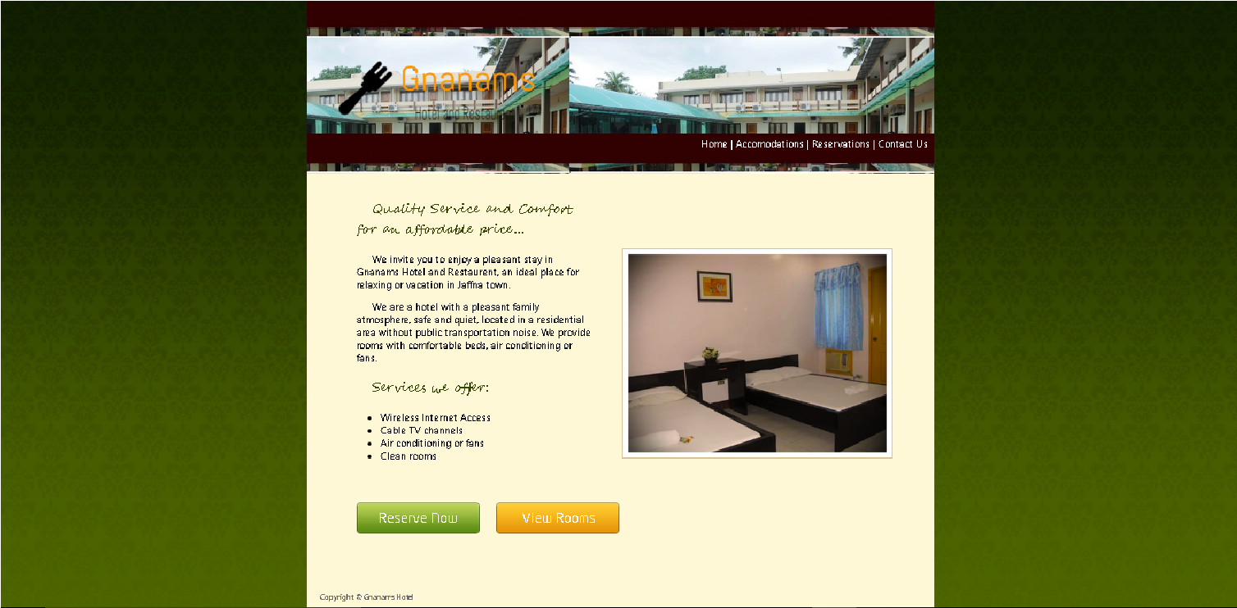

*figure 10: Main Interface*

<!DOCTYPE html PUBLIC "-//W3C//DTD XHTML 1.0 Transitional//EN"

"http://www.w3.org/TR/xhtml1/DTD/xhtml1-transitional.dtd"> <html xmlns="http://www.w3.org/1999/xhtml">

<head>

<meta http-equiv="Content-Type" content="text/html; charset=utf-8" />

<title>Gnanams Hotel</title>

<link href="stylesheet.css" rel="stylesheet" type="text/css" />

<link href="//netdna.bootstrapcdn.com/font-awesome/4.0.3/css/font awesome.css" rel="stylesheet">

</head>

<body>

<div class="main_container" >

<a href="#"><img src="images/logo.png" align="left" /></a>

<div id="headr_img">

<span id="main_nav">

<a href="#">Home</a> |

<a href="catalogue.php">Accomodations</a> |

<a href="reserve.php">Reservations</a> |

<a href="contact.php">Contact Us</a>

</span>

</div>

<div id="content_container">

<div id="welcome">

<p id="home_header">

Quality Service and Comfort for an affordable price...

</p>

<p>We invite you to enjoy a pleasant stay in Gnanams Hotel and Restaurent, an ideal place for relaxing or vacation in Jaffna town.</p>

<p>We are a hotel with a pleasant family atmosphere, safe and quiet, located in a residential area without public transportation noise.

We provide rooms with comfortable beds, air conditioning or fans.</p>

<p id="home_header">Services we offer:</p>

<ul>

<li><i class="icon-li icon-ok"></i>Wireless Internet Access</li>

<li>Cable TV channels</li>

<li>Air conditioning or fans</li>

<li>Clean rooms</li>

</ul>

</div>

<span id="img_shadow"><img src="images/1011_n.png"/></span>

<div class="call_to_action" id="grn"><a href="reserve.php">ReserveNow</a></div> <div class="call_to_action" id="orn"><a href="catalogue.php">View

Rooms</a></div>

</div>

<div id="footer_container">

<strong>Copyright © Gnanams Hotel </strong> </div>

</div>

</body>

**</**html**>**

 **Accommodation and facilities**

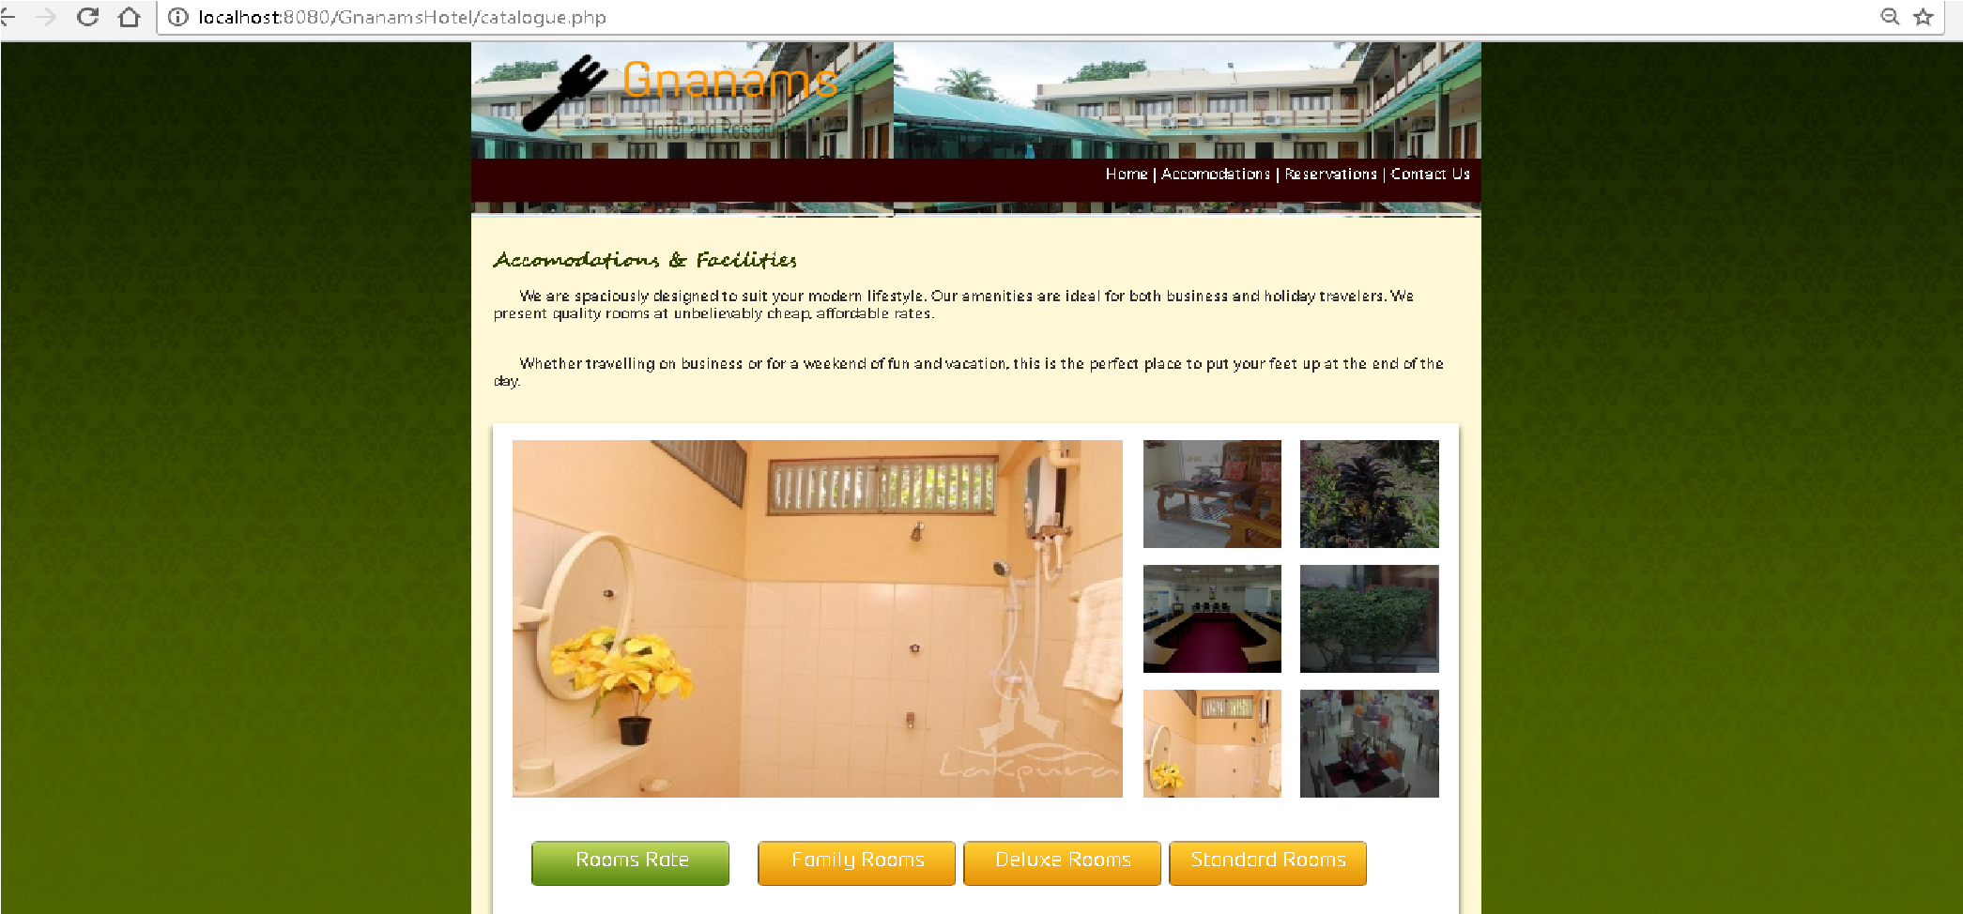

*figure 11: Accommodation and facilities*

<!DOCTYPE html PUBLIC "-//W3C//DTD XHTML 1.0 Transitional//EN"

"http://www.w3.org/TR/xhtml1/DTD/xhtml1-transitional.dtd">

<html xmlns="http://www.w3.org/1999/xhtml">

<head>

<meta http-equiv="Content-Type" content="text/html; charset=utf-8" /> <title>Gnamans Hotel</title>

<link href="stylesheet.css" rel="stylesheet" type="text/css" />

<link rel="stylesheet" href="css/reset.css" type="text/css"

media="screen" />

<link rel="stylesheet" href="css/style.css" type="text/css"

media="screen" />

<link rel="stylesheet" href="css/grid.css" type="text/css"

media="screen" />

<script src="js/jquery-1.6.2.min.js" type="text/javascript"></script>

<script src="js/jquery.easing.1.3.js" type="text/javascript"></script>

<script src="js/jcarousellite_1.0.1.js" type="text/javascript"></script>

<script src="js/jquery.galleriffic.js" type="text/javascript"></script>

<script src="js/jquery.opacityrollover.js" type="text/javascript"></script>

<script type="text/javascript">

$(document).ready(function() {

$(".jCarouselLite").jCarouselLite({ btnNext: ".next",

btnPrev: ".prev", speed: 400,

vertical: false, circular: true, easing:'easeOutQuart', visible: 4, start: 0, scroll: 1

});

});

</script>

</head>

<body>

<div class="main_container" >

<a href="index.php"><img src="images/logo.png" align="left" /></a>

<div id="headr_img">

<span id="main_nav">

<a href="index.php">Home</a> |

<a href="#">Accomodations</a> |

<a href="reserve.php">Reservations</a> | <a href="contact.php">Contact Us</a>

</span> </div>

<!-- content -->

<section id="content">

<div class="bg-top">

<div class="bg-top-2">

<div class="bg">

<div class="bg-top-shadow">

<div class="main">

<h4 id="home_header">Accomodations & Facilities</h4><br />

<p style="font-size:16px;">We are spaciously designed to suit your modern lifestyle. Our amenities are ideal for both business and holiday travelers. We present quality rooms at unbelievably cheap, affordable rates.</p><br/>

<p style="font-size:16px;">Whether travelling on business or for a weekend of fun and vacation, this is the perfect place to put your feet up at the end of the day.</p><br/>

<div class="gallery p3">

<div class="wrapper indent-bot">

<div id="gallery" class="content">

<div class="wrapper">

<div class="slideshow-container">

<div id="slideshow" class="slideshow"></div>

</div>

</div>

</div>

<div id="thumbs" class="navigation">

<ul class="thumbs noscript">

<li>

<a class="thumb" href="images2/p1.jpg" title=""> <img src="images2/thumb-1.jpg" alt="" /><span></span> </a>

</li>

<li>

<a class="thumb" href="images2/p2.jpg" title=""> <img src="images2/thumb-2.jpg" alt="" /> <span></span></a>

</li>

<li>

<a class="thumb" href="images2/p3.jpg" title=""> <img src="images2/thumb3.jpg" alt="" /> <span></span></a>

</li>

<li>

<a class="thumb" href="images2/p4.jpg" title=""> <img src="images2/thumb-4.jpg" alt="" /> <span></span></a>

</li>

<li>

<a class="thumb" href="images2/p5.jpg" title=""> <img src="images2/thumb5.jpg" alt="" /> <span></span></a>

</li>

<li>

<a class="thumb" href="images2/p6.jpg" title=""> <img src="images2/thumb6.jpg" alt="" /> <span></span></a>

</li>

</ul>

</div>

</div>

<div class="inner-2">

<div class="call_to_action" id="grn"><a href="pricing.php">Rooms Rate</a></div>

<div class="call_to_action" id="orn"><a href="family.php">Family

Rooms</a></div>

<div class="call_to_action" id="orn"><a href="deluxe.php">Deluxe

Rooms</a></div>

<div class="call_to_action" id="orn"><a href="standard.php">Standard

Rooms</a></div>

</div>

</div>

</div>

</div>

</div>

</div> </div>

</section>

<script type="text/javascript">

$(window).load(function() {

// We only want these styles applied when javascript is enabled

$('div.navigation').css({'width' : '320px', 'float' : 'right'});

$('div.content').css('display', 'block');

// Initially set opacity on thumbs and add // additional styling for hover effect on thumbs var onMouseOutOpacity = 0.5;

$('#thumbs ul.thumbs li span').opacityrollover({ mouseOutOpacity: onMouseOutOpacity, mouseOverOpacity: 0.0,

fadeSpeed: 'fast', exemptionSelector: '.selected'

});

// Initialize Advanced Galleriffic Gallery var gallery = $('#thumbs').galleriffic({

delay: 7000, numThumbs: 12, preloadAhead: 6, enableTopPager: false, enableBottomPager: false, imageContainerSel: '#slideshow', controlsContainerSel: '', captionContainerSel: '', loadingContainerSel: '', renderSSControls: true, renderNavControls: true, playLinkText: 'Play Slideshow', pauseLinkText: 'Pause Slideshow', prevLinkText: 'Prev', nextLinkText: 'Next', nextPageLinkText: 'Next', prevPageLinkText: 'Prev', enableHistory: true, autoStart: 7000, syncTransitions: true, defaultTransitionDuration: 900, onSlideChange: function(prevIndex, nextIndex) {

// 'this' refers to the gallery, which is an extension of $

('#thumbs') this.find('ul.thumbs li span')

.css({opacity:0.5})

}, onPageTransitionOut: function(callback) { this.find('ul.thumbs li span').css({display:'block'});

},

onPageTransitionIn: function() { this.find('ul.thumbs li span').css({display:'none'});

}

});

});

</script>

<div id="footer_container">

Copyright © 2017 Gnanams Hotel

</div>

</div>

</body>

**</**html**>**

###  Reservation list form

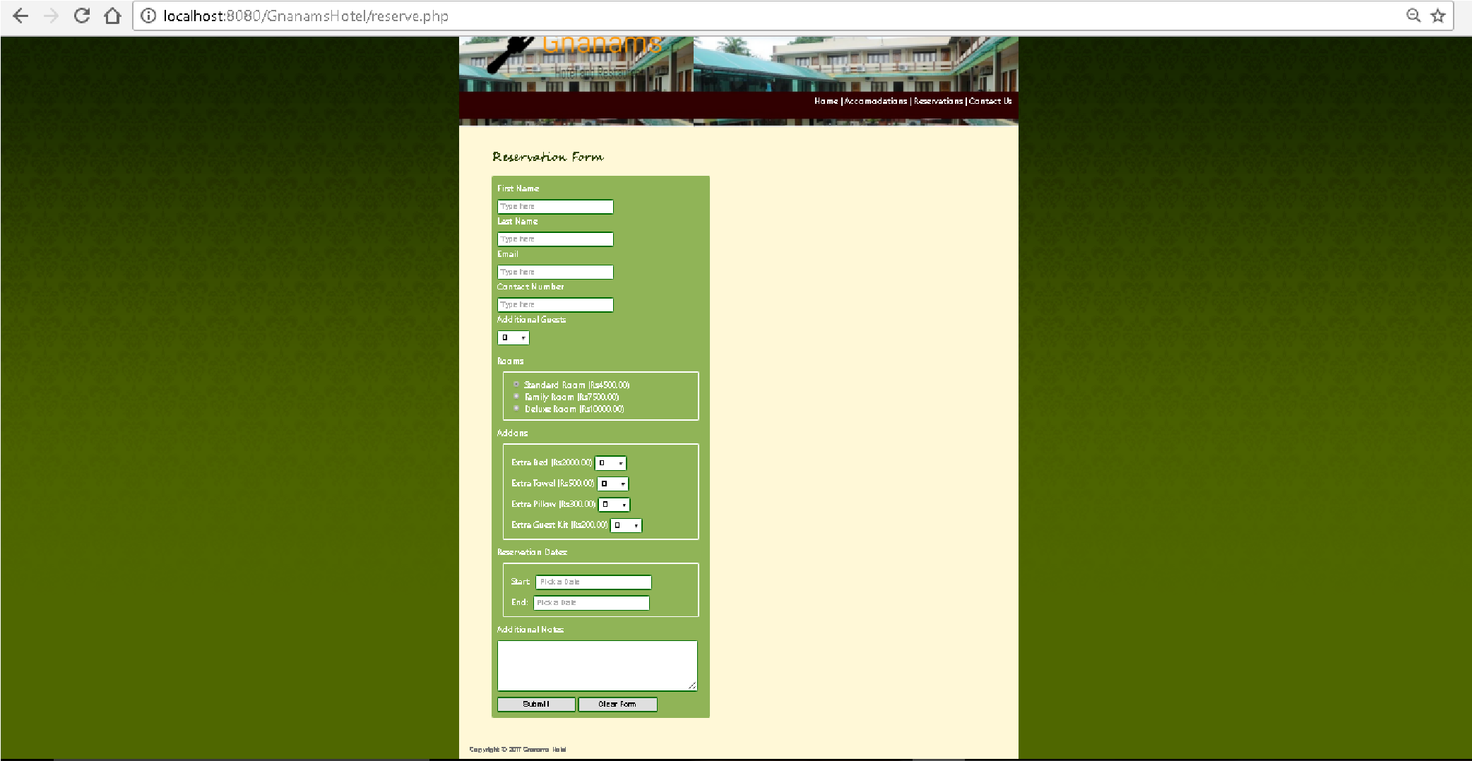

*figure 12: Reservation list form*

<?php require_once('Connections/localhost.php'); ?>

<?php

if (!function_exists("GetSQLValueString")) { function GetSQLValueString($theValue, $theType, $theDefinedValue = "",

$theNotDefinedValue = "")

{ if (PHP_VERSION < 6) {

$theValue = get_magic_quotes_gpc() ? stripslashes($theValue) : $theValue;

}

$theValue = function_exists("mysql_real_escape_string") ?

mysql_real_escape_string($theValue) : mysql_escape_string($theValue); switch ($theType) { case "text":

$theValue = ($theValue != "") ? "'" . $theValue . "'" : "NULL";

break; case "long": case "int":

$theValue = ($theValue != "") ? intval($theValue) : "NULL";

break; case "double":

$theValue = ($theValue != "") ? doubleval($theValue) : "NULL";

break;

case "date":

$theValue = ($theValue != "") ? "'" . $theValue . "'" : "NULL";

break; case "defined":

$theValue = ($theValue != "") ? $theDefinedValue : $theNotDefinedValue;

break;

}

return $theValue;

}

}

$editFormAction = $_SERVER['PHP_SELF']; if (isset($_SERVER['QUERY_STRING'])) {

$editFormAction .= "?" . htmlentities($_SERVER['QUERY_STRING']);

} if ((isset($_POST["MM_insert"])) && ($_POST["MM_insert"] == "form1"))

{

$insertSQL = sprintf("INSERT INTO reservations (rsrv_id,

rsrv_timestamp, rsrv_first_name, rsrv_last_name, rsrv_email, rsrv_contact, rsrv_room, rsrv_bed, rsrv_pillow, rsrv_towel, rsrv_kit, rsrv_start, rsrv_end, rsrv_guest, rsrv_notes) VALUES (%s, %s, %s, %s, %s, %s, %s, %s, %s, %s, %s, %s, %s, %s, %s)",

GetSQLValueString($_POST['rsrv_id'], "int"),

GetSQLValueString($_POST['rsrv_timestamp'], "date"),

GetSQLValueString($_POST['rsrv_first_name'], "text"),

GetSQLValueString($_POST['rsrv_last_name'], "text"),

GetSQLValueString($_POST['rsrv_email'], "text"),

GetSQLValueString($_POST['rsrv_contact'], "int"),

GetSQLValueString($_POST['rsrv_room'], "text"),

GetSQLValueString($_POST['rsrv_bed'], "int"),

GetSQLValueString($_POST['rsrv_pillow'], "int"),

GetSQLValueString($_POST['rsrv_towel'], "int"),

GetSQLValueString($_POST['rsrv_kit'], "int"),

GetSQLValueString($_POST['rsrv_start'], "date"),

GetSQLValueString($_POST['rsrv_end'], "date"),

GetSQLValueString($_POST['rsrv_guest'], "int"),

GetSQLValueString($_POST['rsrv_notes'], "text")); mysql_select_db($database_localhost, $localhost);

$Result1 = mysql_query($insertSQL, $localhost) or die(mysql_error()); $insertGoTo = "reservation/thank-you.php?rsrv_id=$_POST[rsrv_id]"; if (isset($_SERVER['QUERY_STRING'])) {

$insertGoTo .= (strpos($insertGoTo, '?')) ? "&" : "?";

$insertGoTo .= $_SERVER['QUERY_STRING'];

}

header(sprintf("Location: %s", $insertGoTo));

}

?>

<!DOCTYPE html PUBLIC "-//W3C//DTD XHTML 1.0 Transitional//EN"

"http://www.w3.org/TR/xhtml1/DTD/xhtml1-transitional.dtd">

<html xmlns="http://www.w3.org/1999/xhtml"><head>

<meta http-equiv="Content-Type" content="text/html; charset=utf-8" /> <title>Gnanams Hotel</title>

<link href="stylesheet.css" rel="stylesheet" type="text/css" />

<link rel="stylesheet" type="text/css" media="all"

href="includes/jquery/jquery-ui-custom.css" />

<script src="includes/jquery/jquery-1.10.2.js"></script>

<script src="includes/jquery/jquery-ui-custom.js"></script>

<script src="includes/jquery/maskedinput.js"></script>

<script src="includes/bootstrap/js/bootstrap.js"></script>

<script src="SpryAssets/SpryValidationTextField.js" type="text/javascript"></script>

<script> jQuery(document).ready(function($) {var dateToday = new Date(); var dates = $("#dateStart, #dateEnd").datepicker({ defaultDate: "+1w", dateFormat: 'yy-mm-dd', changeMonth: true, numberOfMonths: 1, minDate: dateToday,

onSelect: function(selectedDate) { var option = this.id == "dateStart" ? "minDate" : "maxDate", instance = $(this).data("datepicker"), date = $.datepicker.parseDate(instance.settings.dateFormat || $.datepicker.settings.dateFormat, selectedDate, instance.settings); dates.not(this).datepicker("option", option, date);

}

});

});

</script>

<script type="text/javascript"> jQuery(function($){

$("#rsrv_contact").mask("99999999999");

});

</script>

<link href="SpryAssets/SpryValidationTextField.css" rel="stylesheet" type="text/css" />

</head>

<body>

<div class="main_container" >

<a href="index.php"><img src="images/logo.png" align="left" /></a>

<div id="headr_img">

<span id="main_nav">

<a href="index.php">Home</a> |

<a href="catalogue.php">Accomodations</a> |

<a href="reserve.php">Reservations</a> | <a href="contact.php">Contact Us</a>

</span> </div>

<div id="content_container">

<div id="content_left">

<h2 id="home_header">Reservation Form</h2>

<form action="<?php echo $editFormAction; ?>" method="POST" name="form1" id="rsrv_form">

<label>First Name</label><br />

<span id="sprytextfield1">

<input type="text" name="rsrv_first_name" value="" size="30" placeholder="Type here" />

<span class="textfieldRequiredMsg">This field is

required</span></span><br/>

<label>Last Name</label><br />

<span id="sprytextfield2">

<input type="text" name="rsrv_last_name" value="" size="30" placeholder="Type here" />

<span class="textfieldRequiredMsg">This field is required</span></span><br/><label>Email</label><br />

<input type="text" name="rsrv_email" value="" size="30"

placeholder="Type here" /><br />

<label>Contact Number</label><br />

<span id="sprytextfield3">

<input type="text" name="rsrv_contact" value="" size="30" id="rsrv_contact" placeholder="Type here" />

<span class="textfieldRequiredMsg">This field is

required</span></span><br />

<label>Additional Guests</label></br>

<select name="rsrv_guest" size="1" id="select" placeholder="Select">

<option value="0">0</option>

<option value="1">1</option>

<option value="2">2</option>

<option value="3">3</option>

<option value="4">4</option>

<option value="5">5</option>

<option value="6">6</option>

<option value="7">7</option>

<option value="8">8</option>

<option value="9">9</option>

<option value="10">10</option> <option value="11">11</option>

<option value="12">12</option>

<values> </select> <br /><br />

<label>Rooms</label>

<fieldset><label>

<input name="rsrv_room" type="radio" id="rsrv_room_1" value="Standard" checked="checked" />

Standard Room (Rs4500.00)</label><br/>

<label>

<input type="radio" name="rsrv_room" value="Family" id="rsrv_room_2" />

Family Room (Rs7500.00)</label><br/>

<label>

<input type="radio" name="rsrv_room" value="Deluxe" id="rsrv_room_3" />

Deluxe Room (Rs10000.00)</label><br/>

</fieldset>

<label>Addons</label>

<fieldset>

<label>Extra Bed (Rs2000.00)

<select name="rsrv_bed" id="rsrv_bed">

<option value="0">0</option>

<option value="1">1</option>

<option value="2">2</option>

<option value="3">3</option>

<option value="4">4</option>

<option value="5">5</option>

<values>

</select>

</label><br/>

<label>Extra Towel (Rs500.00)

<select name="rsrv_towel" id="rsrv_towel">

<option value="0">0</option>

<option value="1">1</option>

<option value="2">2</option>

<option value="3">3</option>

<option value="4">4</option>

<option value="5">5</option> <option value="6">6</option>

<option value="7">7</option>

<option value="8">8</option>

<option value="9">9</option>

<values>

</select>

</label><br/>

<label>Extra Pillow (Rs300.00)

<select name="rsrv_pillow" id="rsrv_pillow">

<option value="0">0</option>

<option value="1">1</option>

<option value="2">2</option>

<option value="3">3</option>

<option value="4">4</option>

<option value="5">5</option>

<option value="6">6</option>

<option value="7">7</option>

<option value="8">8</option>

<option value="9">9</option>

<values>

</select>

</label><br/>

<label>Extra Guest Kit (Rs200.00)

<select name="rsrv_kit" id="rsrv_kit">

<option value="0">0</option>

<option value="1">1</option>

<option value="2">2</option>

<option value="3">3</option>

<option value="4">4</option>

<option value="5">5</option>

<option value="6">6</option>

<option value="7">7</option>

<option value="8">8</option>

<option value="9">9</option>

<values>

</select>

</label><br/>

</fieldset>

<label>Reservation Dates:</label><br /> <fieldset>

<label>Start:</label> <span id="sprytextfield4">

<input type="text" name="rsrv_start" value="" size="15"

id="dateStart"placeholder="Pick a Date" />

<span class="textfieldRequiredMsg">Please select a

date.</span></span><br />

<label>End:</label>

<span id="sprytextfield5">

<input type="text" name="rsrv_end" value="" size="15" id="dateEnd" placeholder="Pick a Date" />

<span class="textfieldRequiredMsg">Please select a date.</span></span><br/>

<!-- <div class="check_avail"><a href="">Check Availability</a></div> --></fieldset>

<label>Additional Notes:</label><br />

<textarea name="rsrv_notes" cols="40" rows="5"></textarea>

<input type="submit" value="Submit" /> <input name="Reset" type="reset" value="Clear

Form" />

<input type="hidden" name="rsrv_id" value="" />

<input type="hidden" name="rsrv_timestamp" />

<input type="hidden" name="MM_insert" value="form1" /> </form>

</div>

<div id="content_right"> </div>

</div>

<div id="footer_container">

Copyright © 2017 Gnanams Hotel

</div>

</div>

<script type="text/javascript"> var sprytextfield1 = new Spry.Widget.ValidationTextField("sprytextfield1");

var sprytextfield2 = new Spry.Widget.ValidationTextField("sprytextfield2"); var sprytextfield3 = new Spry.Widget.ValidationTextField("sprytextfield3"); var sprytextfield4 = new Spry.Widget.ValidationTextField("sprytextfield4"); var sprytextfield5 = new Spry.Widget.ValidationTextField("sprytextfield5");

</script>

</body>

**</**html**>**

###  Hotel Contact details

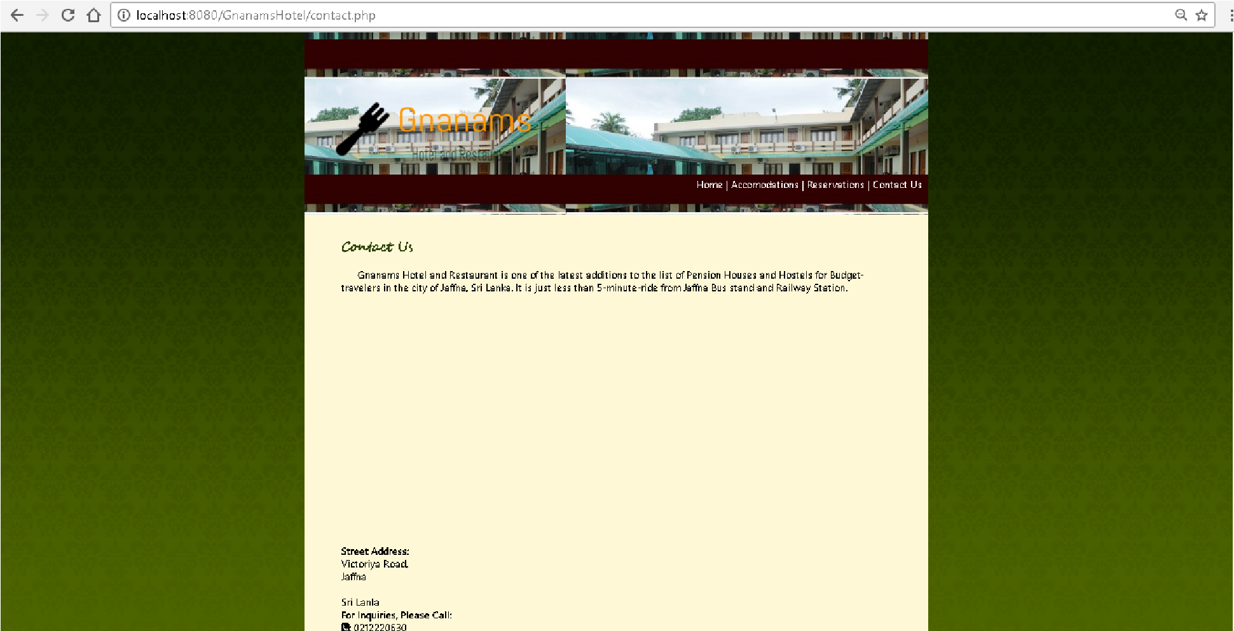

*figure 13: Hotel Contact details*

<?php require_once('Connections/localhost.php'); ?>

<!DOCTYPE html PUBLIC "-//W3C//DTD XHTML 1.0 Transitional//EN"

"http://www.w3.org/TR/xhtml1/DTD/xhtml1-transitional.dtd">

<html xmlns="http://www.w3.org/1999/xhtml"><head>

<meta http-equiv="Content-Type" content="text/html; charset=utf-8" /> <title>gnanams Hotel</title>

<link href="stylesheet.css" rel="stylesheet" type="text/css" /> <link href="//netdna.bootstrapcdn.com/font-awesome/4.0.3/css/font-

awesome.css" rel="stylesheet">

<script src="[https://maps.googleapis.com/maps/api/js?](https://maps.googleapis.com/maps/api/js) v=3.exp&sensor=false"></script>

<script src="includes/jquery/jquery-1.10.2.js"></script>

<script src="includes/jquery/jquery-ui-custom.js"></script>

<script src="includes/jquery/maskedinput.js"></script>

<script src="includes/bootstrap/js/bootstrap.js"></script>

<script src="SpryAssets/SpryValidationTextField.js"

type="text/javascript"></script> <script> function initialize() { var myLatlng = newgoogle.maps.LatLng(9.66724300385,80.01433563232); var mapOptions = { zoom: 17, center: myLatlng

}

var map = new google.maps.Map(document.getElementById('map-canvas'), mapOptions); var marker = new google.maps.Marker({ position: myLatlng, map: map, title: 'Hello World!'

});

} google.maps.event.addDomListener(window, 'load', initialize); </script>

</head>

<body>

<div class="main_container" >

<a href="index.php"><img src="images/logo.png" align="left" /></a> <div id="headr_img">

<span id="main_nav">

<a href="index.php">Home</a> |

<a href="catalogue.php">Accomodations</a> |

<a href="reserve.php">Reservations</a> |

<a href="contact.php">Contact Us</a>

</span>

</div>

<div id="content_container">

<h2 id="home_header">Contact Us</h2>

<p>Gnanams Hotel and Restaurant is one of the latest additions to the list of Pension Houses and Hostels for Budget-travelers in the city of Jaffna, Sri Lanka.

It is just less than 5-minute-ride from Jaffna Bus stand and Railway Station. </p>

<div id="map-canvas"></div><br />

<strong>Street Address:</strong><br />

Victoriya Road,<br/>

Jaffna<br/>

<br/> Sri Lanla<br/>

<strong>For Inquiries, Please Call:</strong><br/>

<strong><i class="fa fa-phone-square"></i>:</strong> 0212220630 </div>

<div id="footer_container">

Copyright © Gnanams Hotel

</div>

</div>

</body>

**</**html**>**

 **Admin login page**

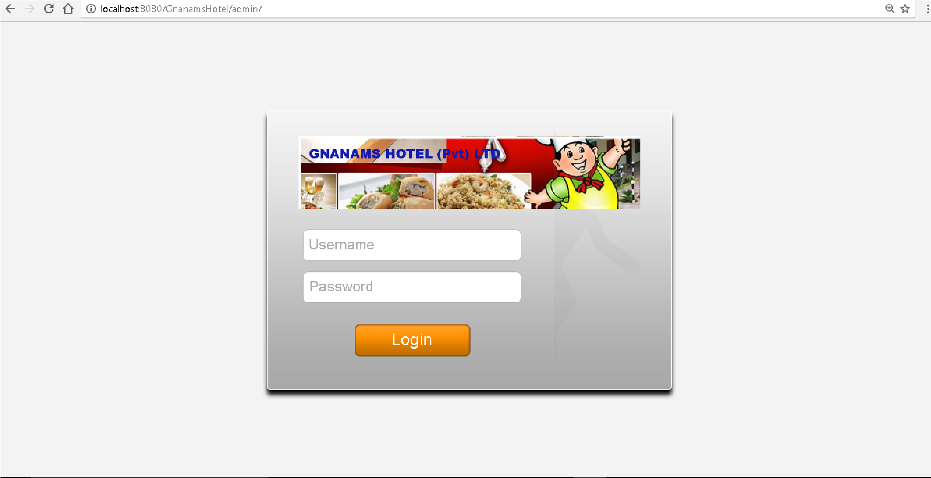

*figure 14: Admin login page*

**Login interface is used to login to the system using username and password for three different users**

<?php require_once('../Connections/localhost.php'); ?>

<?php

//initialize the session

if (!isset($_SESSION)) { session_start(); }

// ** Logout the current user. **

$logoutAction = $_SERVER['PHP_SELF']."?doLogout=true"; if ((isset($_SERVER['QUERY_STRING'])) &&

($_SERVER['QUERY_STRING'] != "")){

$logoutAction .="&". htmlentities($_SERVER['QUERY_STRING']);

} if ((isset($_GET['doLogout'])) &&($_GET['doLogout']=="true")){

//to fully log out a visitor we need to clear the session varialbles

$_SESSION['MM_Username'] = NULL;

$_SESSION['MM_UserGroup'] = NULL; $_SESSION['PrevUrl'] = NULL; unset($_SESSION['MM_Username']); unset($_SESSION['MM_UserGroup']); unset($_SESSION['PrevUrl']);

$logoutGoTo = "index.php"; if ($logoutGoTo) { header("Location: $logoutGoTo"); exit;

}

}

?>

<?php if (!isset($_SESSION)) { session_start();

}

$MM_authorizedUsers = "admin";

$MM_donotCheckaccess = "false";

// *** Restrict Access To Page: Grant or deny access to this page function isAuthorized($strUsers, $strGroups, $UserName, $UserGroup) { // For security, start by assuming the visitor is NOT authorized.

$isValid = False;

// When a visitor has logged into this site, the Session variable MM_Username set equal to their username.

// Therefore, we know that a user is NOT logged in if that Session variable is blank.

if (!empty($UserName)) {

// Besides being logged in, you may restrict access to only certain users

based on an ID established when they login.

// Parse the strings into arrays.

$arrUsers = Explode(",", $strUsers); $arrGroups = Explode(",", $strGroups); if (in_array($UserName, $arrUsers)) {

$isValid = true; }

// Or, you may restrict access to only certain users based on their username. if (in_array($UserGroup, $arrGroups)) {

$isValid = true;

}

if (($strUsers == "") && false) {

$isValid = true;

} } return $isValid;

}

$MM_restrictGoTo = "access_denied.php"; if (!((isset($_SESSION['MM_Username'])) && (isAuthorized("",

$MM_authorizedUsers, $_SESSION['MM_Username'],

$_SESSION['MM_UserGroup'])))) {

$MM_qsChar = "?";

$MM_referrer = $_SERVER['PHP_SELF']; if (strpos($MM_restrictGoTo, "?")) $MM_qsChar = "&"; if (isset($_SERVER['QUERY_STRING']) && strlen($_SERVER['QUERY_STRING']) > 0)

$MM_referrer .= "?" . $_SERVER['QUERY_STRING'];

$MM_restrictGoTo = $MM_restrictGoTo. $MM_qsChar . "accesscheck=" .

urlencode($MM_referrer);

header("Location: ". $MM_restrictGoTo); exit;

}

?>

<?php

if (!function_exists("GetSQLValueString")) { function GetSQLValueString($theValue, $theType, $theDefinedValue = "",

$theNotDefinedValue = "")

{ if (PHP_VERSION < 6) {

$theValue = get_magic_quotes_gpc() ? stripslashes($theValue) : $theValue;

}

//$theValue = function_exists("mysql_real_escape_string") ? mysql_real_escape_string($theValue) : mysql_escape_string($theValue);

$localhost = mysqli_connect("localhost", "root", "", "gnanams_db"); $theValue = mysqli_real_escape_string($localhost, $theValue); switch ($theType) { case "text":

$theValue = ($theValue != "") ? "'" . $theValue . "'" : "NULL"; break; case "long": case "int":

$theValue = ($theValue != "") ? intval($theValue) : "NULL"; break;

case "double":

$theValue = ($theValue != "") ? doubleval($theValue) : "NULL"; break; case "date":

$theValue = ($theValue != "") ? "'" . $theValue . "'" : "NULL";

break; case "defined": $theValue = ($theValue != "") ? $theDefinedValue :$theNotDefinedValue; break; } return $theValue;

}

}

$maxRows_user = 5; $pageNum_user = 0; if (isset($_GET['pageNum_user'])) { $pageNum_user = $_GET['pageNum_user'];

}

$startRow_user = $pageNum_user * $maxRows_user; mysqli_select_db($localhost, $database_localhost);

$query_user = "SELECT * FROM `user`";

$query_limit_user = sprintf("%s LIMIT %d, %d", $query_user, $startRow_user, $maxRows_user);

$user = mysqli_query($localhost, $query_limit_user) or

die(mysqli_error($loalhost));

$row_user = mysqli_fetch_assoc($user); if (isset($_GET['totalRows_user'])) { $totalRows_user = $_GET['totalRows_user'];

} else {

$all_user = mysqli_query($localhost, $query_user);

$totalRows_user = mysqli_num_rows($all_user);

}

$totalPages_user = ceil($totalRows_user/$maxRows_user)-1;

?>

<!DOCTYPE html PUBLIC "-//W3C//DTD XHTML 1.0 Transitional//EN"

"http://www.w3.org/TR/xhtml1/DTD/xhtml1-transitional.dtd">

<html xmlns="http://www.w3.org/1999/xhtml">

<head>

<meta http-equiv="Content-Type" content="text/html; charset=utf-8" />

<link rel="stylesheet" type="text/css" href="style/stylesheet.css" /> <link href="//netdna.bootstrapcdn.com/font-awesome/4.0.3/css/font-

awesome.css" rel="stylesheet">

<title>Admin Panel - Gnanams Hotel</title>

</head>

<body>

<div class="top_container">

<span id="panel_name">Admin Panel</span>

<span id="user">Welcome, <?php echo $row_user['user_full']; ?><br/><a href="<?php echo $logoutAction ?>">Log out</a></span>

</div>

<ul id="menu">

<li>

<a href="admin_panel.php"><i class="fa fa-home"></i> Home</a>

</li>

<li>

<a href="records.php"><i class="fa fa-list-alt"></i> Records</a>

</li>

<li>

<a href="users.php"><i class="fa fa-users"></i> User Management</a>

</li> </ul>

<div id="container">

<h2><i class="fa fa-bars"></i> User Management</h2>

<i class="fa fa-plus-circle"></i> <a href="add_user.php">Add New

User</a> <i class="fa fa-plus-circle"></i> <a href="delete_usr.php">Delete User</a> <table cellpadding="0" cellspacing="0" class="data_table">

<tr id="tr">

<td>Full Name</td>

<td>Username</td>

<td>Role</td>

<!-- <td>Actions</td>-->

</tr>

<?php do { ?>

<tr>

<td><?php echo $row_user['user_full']; ?></td>

<td><?php echo $row_user['user_name']; ?></td>

<td><?php echo $row_user['user_role']; ?></td>

<!--<td><a href=""><i class="fa fa-edit"></i></a> | <a href="delete_usr.php? user_id=<?php echo $row_user['user_id']; ?>"><i

class="fa fa-trash-o"></i></a></td>-->

</tr>

<?php } while ($row_user = mysqli_fetch_assoc($user)); ?>

</table></div>

</body>

</html> <?php

mysqli_free_result($user);

**?>**

 **Other needed codings.**

 **Admin panel**

<?php require_once('../Connections/localhost.php'); ?>

<?php

//initialize the session if (!isset($_SESSION)) { session_start();

}

// ** Logout the current user. **

$logoutAction = $_SERVER['PHP_SELF']."?doLogout=true";

if ((isset($_SERVER['QUERY_STRING'])) &&

($_SERVER['QUERY_STRING'] != "")){

$logoutAction .="&". htmlentities($_SERVER['QUERY_STRING']);

} if ((isset($_GET['doLogout'])) &&($_GET['doLogout']=="true")){

//to fully log out a visitor we need to clear the session varialbles

$_SESSION['MM_Username'] = NULL;

$_SESSION['MM_UserGroup'] = NULL; $_SESSION['PrevUrl'] = NULL;

unset($_SESSION['MM_Username']); unset($_SESSION['MM_UserGroup']); unset($_SESSION['PrevUrl']); $logoutGoTo = "index.php"; if ($logoutGoTo) { header("Location: $logoutGoTo"); exit;

}

}

?>

<?php if (!isset($_SESSION)) {

session_start();

}

$MM_authorizedUsers = "admin";

$MM_donotCheckaccess = "false";

// *** Restrict Access To Page: Grant or deny access to this page function isAuthorized($strUsers, $strGroups, $UserName, $UserGroup) { // For security, start by assuming the visitor is NOT authorized.

$isValid = False;

// When a visitor has logged into this site, the Session variable MM_Username set equal to their username.

// Therefore, we know that a user is NOT logged in if that Session variable is blank.

if (!empty($UserName)) {

// Besides being logged in, you may restrict access to only certain users

based on an ID established when they login.

// Parse the strings into arrays.

$arrUsers = Explode(",", $strUsers); $arrGroups = Explode(",", $strGroups); if (in_array($UserName, $arrUsers)) {

$isValid = true;

}

// Or, you may restrict access to only certain users based on their username. if (in_array($UserGroup, $arrGroups)) {

$isValid = true;

}

if (($strUsers == "") && false) {

$isValid = true;

} } return $isValid;

}

$MM_restrictGoTo = "access_denied.php"; if (!((isset($_SESSION['MM_Username'])) && (isAuthorized("", $MM_authorizedUsers, $_SESSION['MM_Username'],

$_SESSION['MM_UserGroup'])))) {

$MM_qsChar = "?";

$MM_referrer = $_SERVER['PHP_SELF']; if (strpos($MM_restrictGoTo, "?")) $MM_qsChar = "&"; if (isset($_SERVER['QUERY_STRING']) && strlen($_SERVER['QUERY_STRING']) > 0)

$MM_referrer .= "?" . $_SERVER['QUERY_STRING'];

$MM_restrictGoTo = $MM_restrictGoTo. $MM_qsChar . "accesscheck=" .

urlencode($MM_referrer);

header("Location: ". $MM_restrictGoTo); exit;

}

?>

<?php

if (!function_exists("GetSQLValueString")) { function GetSQLValueString($theValue, $theType, $theDefinedValue = "",

$theNotDefinedValue = "")

{ if (PHP_VERSION < 6) {

$theValue = get_magic_quotes_gpc() ? stripslashes($theValue) : $theValue;

}

$localhost = mysqli_connect("localhost", "root", "", "gnanams_db"); $theValue = mysqli_real_escape_string($localhost, $theValue); switch ($theType) { case "text":

$theValue = ($theValue != "") ? "'" . $theValue . "'" : "NULL"; break; case "long": case "int":

$theValue = ($theValue != "") ? intval($theValue) : "NULL"; break;

case "double":

$theValue = ($theValue != "") ? doubleval($theValue) : "NULL"; break; case "date":

$theValue = ($theValue != "") ? "'" . $theValue . "'" : "NULL"; break; case "defined":

$theValue = ($theValue != "") ? $theDefinedValue : $theNotDefinedValue; break;

}

return $theValue;

} } mysqli_select_db($localhost, $database_localhost); $query_user = "SELECT * FROM `user`";

$user = mysqli_query($localhost, $query_user) or die(mysqli_error($loalhost));

$row_user = mysqli_fetch_assoc($user);

$totalRows_user = mysqli_num_rows($user);

$colname_records = "-1"; if (isset($_GET['rsrv_id'])) {

$colname_records = $_GET['rsrv_id'];

} mysqli_select_db($localhost, $database_localhost);

$query_records = sprintf("SELECT * FROM reservations WHERE rsrv_id = %s", GetSQLValueString($colname_records, "int"));

$records = mysqli_query($localhost, $query_records) or die(mysqli_error($loalhost));

$row_records = mysqli_fetch_assoc($records);

$totalRows_records = mysqli_num_rows($records);

?>

<!DOCTYPE html PUBLIC "-//W3C//DTD XHTML 1.0 Transitional//EN"

"http://www.w3.org/TR/xhtml1/DTD/xhtml1-transitional.dtd">

<html xmlns="http://www.w3.org/1999/xhtml">

<head>

<meta http-equiv="Content-Type" content="text/html; charset=utf-8" />

<link rel="stylesheet" type="text/css" href="style/stylesheet.css" />

<link href="//netdna.bootstrapcdn.com/font-awesome/4.0.3/css/fontawesome.css" rel="stylesheet">

<title>Admin Panel - Gnanams Hotel</title>

</head>

<body>

<div class="top_container">

<span id="panel_name">Admin Panel</span>

<span id="user">Welcome, <?php echo $row_user['user_full']; ?><br/><a href="<?php echo $logoutAction ?>">Log out</a></span>

</div>

<ul id="menu">

<li>

<a href="admin_panel.php"><i class="fa fa-home"></i> Home</a>

</li>

<li>

<a href="records.php"><i class="fa fa-list-alt"></i> Records</a>

</li>

<li>

<a href="users.php"><i class="fa fa-users"></i> User Management</a>

</li>

</ul>

<div id="container">

<h2><i class="fa fa-bars"></i> Home E</h2>

<!--<div id="content_left"><a href="report.php?action=3&month="><i class="fa fa-folder-open"></i> Generate Reports</a></div>--> </div>

</body>

</html> <?php

mysqli_free_result($user); mysqli_free_result($records);

?>

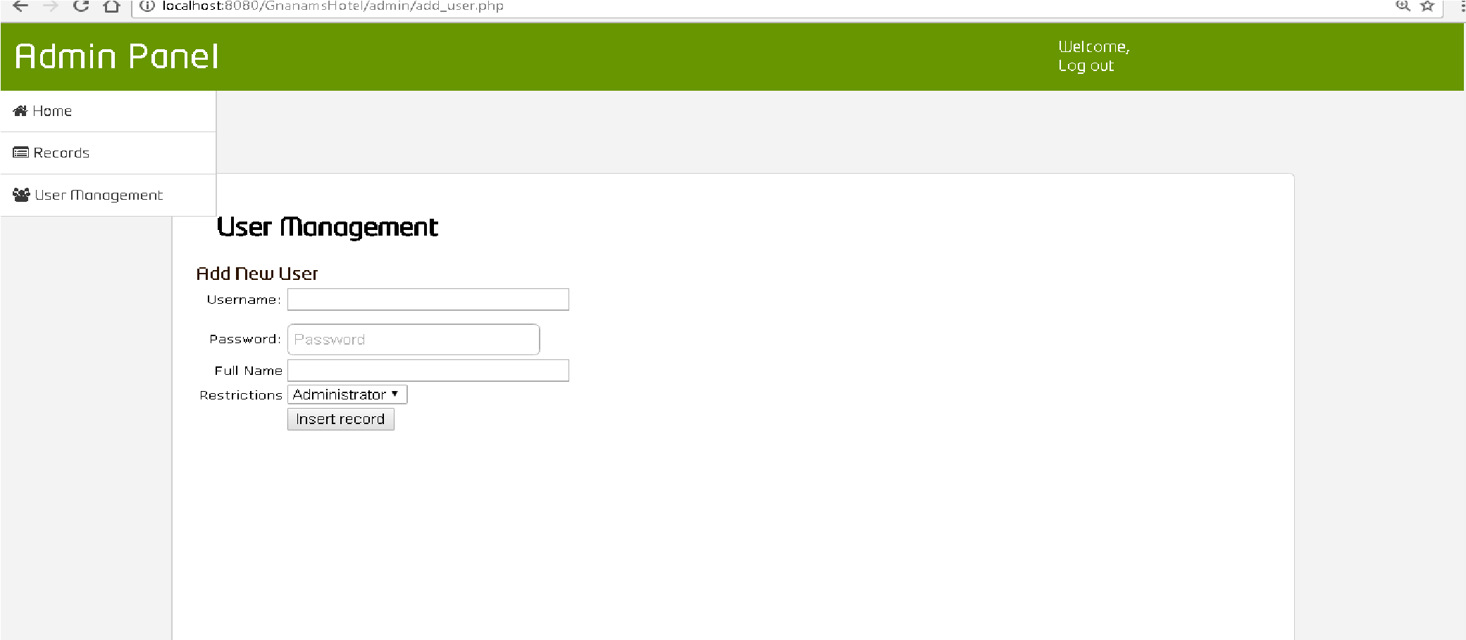

*figure 15: Admin*

**Customer Records**

<?php

if (!isset($_SESSION)) {

session_start();

}

$MM_authorizedUsers = "admin";

$MM_donotCheckaccess = "false";

// *** Restrict Access To Page: Grant or deny access to this page function isAuthorized($strUsers, $strGroups, $UserName, $UserGroup) { // For security, start by assuming the visitor is NOT authorized. $isValid = False;

// When a visitor has logged into this site, the Session variable MM_Username set equal to their username.

// Therefore, we know that a user is NOT logged in if that Session variable is blank. if (!empty($UserName)) {

// Besides being logged in, you may restrict access to only certain users based on an ID established when they login.

// Parse the strings into arrays.

$arrUsers = Explode(",", $strUsers); $arrGroups = Explode(",", $strGroups);

if (in_array($UserName, $arrUsers)) {

$isValid = true;

}

// Or, you may restrict access to only certain users based on their username.

if (in_array($UserGroup, $arrGroups)) {

$isValid = true;

}

if (($strUsers == "") && false) {

$isValid = true;

}

}

return $isValid;

}

$MM_restrictGoTo = "access_denied.php";

if (!((isset($_SESSION['MM_Username'])) && (isAuthorized("",$MM_authorizedUsers,

$_SESSION['MM_Username'], $_SESSION['MM_UserGroup'])))) {

$MM_qsChar = "?";

$MM_referrer = $_SERVER['PHP_SELF'];

if (strpos($MM_restrictGoTo, "?")) $MM_qsChar = "&";

if (isset($_SERVER['QUERY_STRING']) && strlen($_SERVER['QUERY_STRING']) > 0)

$MM_referrer .= "?" . $_SERVER['QUERY_STRING'];

$MM_restrictGoTo = $MM_restrictGoTo. $MM_qsChar . "accesscheck=" .

urlencode($MM_referrer); header("Location: ". $MM_restrictGoTo); exit;

}

?>

<?php require_once('../Connections/localhost.php'); ?>

<?php

//initialize the session if (!isset($_SESSION)) {

session_start(); }

// ** Logout the current user. **

$logoutAction = $_SERVER['PHP_SELF']."?doLogout=true";

if ((isset($_SERVER['QUERY_STRING'])) && ($_SERVER['QUERY_STRING'] != "")){ $logoutAction .="&". htmlentities($_SERVER['QUERY_STRING']);

}

if ((isset($_GET['doLogout'])) &&($_GET['doLogout']=="true")){

//to fully log out a visitor we need to clear the session varialbles

$_SESSION['MM_Username'] = NULL;

$_SESSION['MM_UserGroup'] = NULL; $_SESSION['PrevUrl'] = NULL; unset($_SESSION['MM_Username']); unset($_SESSION['MM_UserGroup']); unset($_SESSION['PrevUrl']);

$logoutGoTo = "index.php"; if ($logoutGoTo) {

header("Location: $logoutGoTo"); exit;

}

}

?>

<?php

if (!function_exists("GetSQLValueString")) {

function GetSQLValueString($theValue, $theType, $theDefinedValue = "",

$theNotDefinedValue = "")

{

if (PHP_VERSION < 6) {

$theValue = get_magic_quotes_gpc() ? stripslashes($theValue) : $theValue;

}

//$theValue = function_exists("mysql_real_escape_string") ? mysql_real_escape_string($theValue) : mysql_escape_string($theValue);

$localhost = mysqli_connect("localhost", "root", "", "gnanams_db"); $theValue = mysqli_real_escape_string($localhost, $theValue);

switch ($theType) { case "text":

$theValue = ($theValue != "") ? "'" . $theValue . "'" : "NULL"; break; case "long":

case "int":

$theValue = ($theValue != "") ? intval($theValue) : "NULL"; break; case "double":

$theValue = ($theValue != "") ? doubleval($theValue) : "NULL"; break; case "date":

$theValue = ($theValue != "") ? "'" . $theValue . "'" : "NULL"; break; case "defined":

$theValue = ($theValue != "") ? $theDefinedValue : $theNotDefinedValue; break;

} return $theValue;

} }

mysqli_select_db($localhost, $database_localhost);

$query_user = "SELECT * FROM `user`";

$user = mysqli_query($localhost, $query_user) or die(mysqli_error($loalhost));

$row_user = mysqli_fetch_assoc($user);

$totalRows_user = mysqli_num_rows($user);

$maxRows_records = 5; $pageNum_records = 0;

if (isset($_GET['pageNum_records'])) {

$pageNum_records = $_GET['pageNum_records'];

}

$startRow_records = $pageNum_records * $maxRows_records;

mysqli_select_db($localhost, $database_localhost);

$query_records = "SELECT *,DATE_FORMAT(rsrv_timestamp, '%M-%e-%Y %r') AS

timeStamp, DATE_FORMAT( rsrv_start, '%M %d, %Y') AS dateStart,

DATE_FORMAT(rsrv_end, '%M %d, %Y') AS dateEnd FROM reservations ORDER BY

reservations.rsrv_timestamp DESC";

$query_limit_records = sprintf("%s LIMIT %d, %d", $query_records, $startRow_records,

$maxRows_records);

$records = mysqli_query($localhost, $query_limit_records) or die(mysqli_error($loalhost));

$row_records = mysqli_fetch_assoc($records);

if (isset($_GET['totalRows_records'])) {

$totalRows_records = $_GET['totalRows_records'];

} else {

$all_records = mysqli_query($localhost, $query_records);

$totalRows_records = mysqli_num_rows($all_records);

}

$totalPages_records = ceil($totalRows_records/$maxRows_records)-1; ?>

<!DOCTYPE html PUBLIC "-//W3C//DTD XHTML 1.0 Transitional//EN"

"http://www.w3.org/TR/xhtml1/DTD/xhtml1-transitional.dtd">

<html xmlns="http://www.w3.org/1999/xhtml">

<head>

<meta http-equiv="Content-Type" content="text/html; charset=utf-8" />

<link rel="stylesheet" type="text/css" href="style/stylesheet.css" />

<link rel="stylesheet" href="style/includes/jquery/jquery-ui-custom.css" />

<script src="style/includes/jquery/jquery-1.10.2.js"></script>

<script src="style/includes/jquery/jquery-ui-custom.js"></script>

<script src="includes/bootstrap/js/bootstrap.js"></script>

<link href="//netdna.bootstrapcdn.com/font-awesome/4.0.3/css/font-awesome.css" rel="stylesheet" />

<script>

jQuery(function($) {

$("#opens_window").click(function(e) { e.preventDefault();

$('#dialog').dialog();

});

});

</script>

<title>Admin Panel - Gnanams Hotel</title>

</head>

<body>

<div class="top_container">

<span id="panel_name">Admin Panel</span>

<span id="user">Welcome, <?php echo $row_user['user_full']; ?><br/><a href="<?php echo

$logoutAction ?>">Log out</a> </span></div>

<ul id="menu">

<li>

<a href="admin_panel.php"><i class="fa fa-home"></i> Home</a>

</li>

<li>

<a href="records.php"><i class="fa fa-list-alt"></i> Records</a>

</li> <li>

<a href="users.php"><i class="fa fa-users"></i> User Management</a>

</li>

</ul>

<div id="container">

<h2><i class="fa fa-bars"></i> Records</h2>

<table cellpadding="0" cellspacing="0" class="data_table">

<tr id="tr">

<td>No.</td>

<td>Submitted</td>

<td>First Name</td>

<td>Last Name</td>

<td>Contact No.</td>

<td>Check-In</td>

<td>Check-Out</td>

<td>Room Type</td>

<td>Extra Bed</td>

<td>Extra Towel</td>

<td>Extra Pillow</td>

<td>Guest Kit</td>

<td>Notes</td>

<td>Actions</td>

</tr>

<?php do { ?>

<tr>

<td><?php echo $row_records['rsrv_id']; ?></td>

<td><?php echo $row_records['timeStamp']; ?></td>

<td><?php echo $row_records['rsrv_first_name']; ?></td>

<td><?php echo $row_records['rsrv_last_name']; ?></td>

<td><?php echo $row_records['rsrv_contact']; ?></td>

<td><?php echo $row_records['dateStart']; ?></td>

<td><?php echo $row_records['dateEnd']; ?></td>

<td><?php echo $row_records['rsrv_room']; ?></td>

<td><?php echo $row_records['rsrv_bed']; ?></td>

<td><?php echo $row_records['rsrv_towel']; ?></td>

<td><?php echo $row_records['rsrv_pillow']; ?></td>

<td><?php echo $row_records['rsrv_kit']; ?></td>

<td><?php echo $row_records['rsrv_notes']; ?></td>

<td><a href="reservation_slip.php?id=<?php echo $row_records['rsrv_id']; ?>"><i class="fa fa-print"></i></a> | <a href="edit_rsrv.php?rsrv_id=<?php echo

$row_records['rsrv_id']; ?>"><i class="fa fa-edit"></i></a> | <a href="delete_rsrv.php?

rsrv_id=<?php echo $row_records['rsrv_id']; ?>"><i class="fa fa-trash-o"></i></a></td>

</tr>

<?php } while ($row_records = mysqli_fetch_assoc($records)); ?>

</table>

<!-- <div id="dialog">

<h3>Reservations for</h3>

</div> -->

</div>

</body>

</html> <?php

mysqli_free_result($user);

mysqli_free_result($records);

?>

● **User Management**

<?php require_once('../Connections/localhost.php'); ?>

<?php

//initialize the session if (!isset($_SESSION)) { session_start(); }

// ** Logout the current user. **

$logoutAction = $_SERVER['PHP_SELF']."?doLogout=true"; if ((isset($_SERVER['QUERY_STRING'])) && ($_SERVER['QUERY_STRING'] != "")){

$logoutAction .="&". htmlentities($_SERVER['QUERY_STRING']);

} if ((isset($_GET['doLogout'])) &&($_GET['doLogout']=="true")){

//to fully log out a visitor we need to clear the session varialbles

$_SESSION['MM_Username'] = NULL;

$_SESSION['MM_UserGroup'] = NULL; $_SESSION['PrevUrl'] = NULL; unset($_SESSION['MM_Username']); unset($_SESSION['MM_UserGroup']); unset($_SESSION['PrevUrl']);

$logoutGoTo = "index.php"; if ($logoutGoTo) { header("Location: $logoutGoTo"); exit; }

}

?>

<?php if (!isset($_SESSION)) { session_start();

}

$MM_authorizedUsers = "admin";

$MM_donotCheckaccess = "false";

// *** Restrict Access To Page: Grant or deny access to this page function isAuthorized($strUsers, $strGroups, $UserName, $UserGroup) { // For security, start by assuming the visitor is NOT authorized.

$isValid = False;

// When a visitor has logged into this site, the Session variable MM_Username set equal to their username.

// Therefore, we know that a user is NOT logged in if that Session variable is blank.

if (!empty($UserName)) {

// Besides being logged in, you may restrict access to only certain users based on an ID established when they login.

// Parse the strings into arrays.

$arrUsers = Explode(",", $strUsers); $arrGroups = Explode(",", $strGroups); if (in_array($UserName, $arrUsers)) {

$isValid = true; }

// Or, you may restrict access to only certain users based on their username. if (in_array($UserGroup, $arrGroups)) {

$isValid = true;

}

if (($strUsers == "") && false) {

$isValid = true;

} } return $isValid;

}

$MM_restrictGoTo = "access_denied.php"; if (!((isset($_SESSION['MM_Username'])) && (isAuthorized("",

$MM_authorizedUsers, $_SESSION['MM_Username'],

$_SESSION['MM_UserGroup'])))) {

$MM_qsChar = "?";

$MM_referrer = $_SERVER['PHP_SELF']; if (strpos($MM_restrictGoTo, "?")) $MM_qsChar = "&"; if (isset($_SERVER['QUERY_STRING']) && strlen($_SERVER['QUERY_STRING']) > 0) $MM_referrer .= "?" . $_SERVER['QUERY_STRING']; $MM_restrictGoTo = $MM_restrictGoTo. $MM_qsChar . "accesscheck=" . urlencode($MM_referrer); header("Location: ". $MM_restrictGoTo);

exit;

}

?>

<?php

if (!function_exists("GetSQLValueString")) { function GetSQLValueString($theValue, $theType, $theDefinedValue = "",

$theNotDefinedValue = "")

{ if (PHP_VERSION < 6) {

$theValue = get_magic_quotes_gpc() ? stripslashes($theValue) : $theValue; }

//$theValue = function_exists("mysql_real_escape_string") ? mysql_real_escape_string($theValue) : mysql_escape_string($theValue);

$localhost = mysqli_connect("localhost", "root", "", "gnanams_db");

$theValue = mysqli_real_escape_string($localhost, $theValue);

switch ($theType) { case "text":

$theValue = ($theValue != "") ? "'" . $theValue . "'" : "NULL"; break; case "long": case "int":

$theValue = ($theValue != "") ? intval($theValue) : "NULL"; break; case "double":

$theValue = ($theValue != "") ? doubleval($theValue) : "NULL"; break; case "date":

$theValue = ($theValue != "") ? "'" . $theValue . "'" : "NULL"; break; case "defined":

$theValue = ($theValue != "") ? $theDefinedValue : $theNotDefinedValue;

break;

} return $theValue;

}

}

$maxRows_user = 5; $pageNum_user = 0; if (isset($_GET['pageNum_user'])) { $pageNum_user = $_GET['pageNum_user'];

}

$startRow_user = $pageNum_user * $maxRows_user;

mysqli_select_db($localhost, $database_localhost);

$query_user = "SELECT * FROM `user`";

$query_limit_user = sprintf("%s LIMIT %d, %d", $query_user, $startRow_user,

$maxRows_user);

$user = mysqli_query($localhost, $query_limit_user) or die(mysqli_error($loalhost));

$row_user = mysqli_fetch_assoc($user);

if (isset($_GET['totalRows_user'])) { $totalRows_user = $_GET['totalRows_user'];

} else {

$all_user = mysqli_query($localhost, $query_user);

$totalRows_user = mysqli_num_rows($all_user);

}

$totalPages_user = ceil($totalRows_user/$maxRows_user)-1;

?>

<!DOCTYPE html PUBLIC "-//W3C//DTD XHTML 1.0 Transitional//EN"

"http://www.w3.org/TR/xhtml1/DTD/xhtml1-transitional.dtd">

<html xmlns="http://www.w3.org/1999/xhtml">

<head>

<meta http-equiv="Content-Type" content="text/html; charset=utf-8" />

<link rel="stylesheet" type="text/css" href="style/stylesheet.css" />

<link href="//netdna.bootstrapcdn.com/font-awesome/4.0.3/css/font-awesome.css" rel="stylesheet">

<title>Admin Panel - Gnanams Hotel</title>

</head>

<body>

<div class="top_container">

<span id="panel_name">Admin Panel</span>

<span id="user">Welcome, <?php echo $row_user['user_full']; ?><br/><a href="<?

php echo $logoutAction ?>">Log out</a></span>

</div>

<ul id="menu">

<li>

<a href="admin_panel.php"><i class="fa fa-home"></i> Home</a>

</li>

<li>

<a href="records.php"><i class="fa fa-list-alt"></i> Records</a>

</li>

<li>

<a href="users.php"><i class="fa fa-users"></i> User Management</a>

</li>

</ul>

<div id="container">

<h2><i class="fa fa-bars"></i> User Management</h2>

<i class="fa fa-plus-circle"></i> <a href="add_user.php">Add New User</a>

<i class="fa fa-plus-circle"></i> <a href="delete_usr.php">Delete User</a>

<table cellpadding="0" cellspacing="0" class="data_table">

<tr id="tr">

<td>Full Name</td>

<td>Username</td>

<td>Role</td>

<!-- <td>Actions</td>-->

</tr>

<?php do { ?>

<tr>

<td><?php echo $row_user['user_full']; ?></td>

<td><?php echo $row_user['user_name']; ?></td>

<td><?php echo $row_user['user_role']; ?></td>

<!--<td><a href=""><i class="fa fa-edit"></i></a> | <a href="delete_usr.php? user_id=<?php echo $row_user['user_id']; ?>"><i class="fa fa-trasho"></i></a></td>-->

</tr>

<?php } while ($row_user = mysqli_fetch_assoc($user)); ?>

</table></div>

</body>

</html> <?php

mysqli_free_result($user);

?>

 **Add user**

<?php require_once('../Connections/localhost.php'); ?>

<?php

//initialize the session if (!isset($_SESSION)) { session_start();

}

// ** Logout the current user. **

$logoutAction = $_SERVER['PHP_SELF']."?doLogout=true"; if ((isset($_SERVER['QUERY_STRING'])) && ($_SERVER['QUERY_STRING'] !

= "")){

$logoutAction .="&". htmlentities($_SERVER['QUERY_STRING']);

}

if ((isset($_GET['doLogout'])) &&($_GET['doLogout']=="true")){

//to fully log out a visitor we need to clear the session varialbles

$_SESSION['MM_Username'] = NULL;

$_SESSION['MM_UserGroup'] = NULL; $_SESSION['PrevUrl'] = NULL; unset($_SESSION['MM_Username']); unset($_SESSION['MM_UserGroup']); unset($_SESSION['PrevUrl']);

$logoutGoTo = "index.php"; if ($logoutGoTo) { header("Location: $logoutGoTo"); exit;

}

}

?>

<?php if (!isset($_SESSION)) { session_start();

}

$MM_authorizedUsers = "admin";

$MM_donotCheckaccess = "false";

// *** Restrict Access To Page: Grant or deny access to this page

function isAuthorized($strUsers, $strGroups, $UserName, $UserGroup) { // For security, start by assuming the visitor is NOT authorized.

$isValid = False;

// When a visitor has logged into this site, the Session variable MM_Username set equal to their username.

// Therefore, we know that a user is NOT logged in if that Session variable is blank.

if (!empty($UserName)) {

// Besides being logged in, you may restrict access to only certain users based on an ID established when they login.

// Parse the strings into arrays.

$arrUsers = Explode(",", $strUsers); $arrGroups = Explode(",", $strGroups); if (in_array($UserName, $arrUsers)) {

$isValid = true; }

// Or, you may restrict access to only certain users based on their username. if (in_array($UserGroup, $arrGroups)) {

$isValid = true;

}

if (($strUsers == "") && false) {

$isValid = true;

} } return $isValid;

}

$MM_restrictGoTo = "access_denied.php"; if (!((isset($_SESSION['MM_Username'])) && (isAuthorized("",

$MM_authorizedUsers, $_SESSION['MM_Username'],

$_SESSION['MM_UserGroup'])))) {

$MM_qsChar = "?";

$MM_referrer = $_SERVER['PHP_SELF']; if (strpos($MM_restrictGoTo, "?")) $MM_qsChar = "&"; if (isset($_SERVER['QUERY_STRING']) && strlen($_SERVER['QUERY_STRING']) > 0)

$MM_referrer .= "?" . $_SERVER['QUERY_STRING'];

$MM_restrictGoTo = $MM_restrictGoTo. $MM_qsChar . "accesscheck=" . urlencode($MM_referrer); header("Location: ". $MM_restrictGoTo);

exit;

}

?>

<?php

if (!function_exists("GetSQLValueString")) { function GetSQLValueString($theValue, $theType, $theDefinedValue = "",

$theNotDefinedValue = "")

{

if (PHP_VERSION < 6) {

$theValue = get_magic_quotes_gpc() ? stripslashes($theValue) : $theValue; }

//$theValue = function_exists("mysql_real_escape_string") ?

mysql_real_escape_string($theValue) : mysql_escape_string($theValue);

$localhost = mysqli_connect("localhost", "root", "", "gnanams_db");

$theValue = mysqli_real_escape_string($localhost, $theValue);

switch ($theType) { case "text":

$theValue = ($theValue != "") ? "'" . $theValue . "'" : "NULL"; break; case "long": case "int":

$theValue = ($theValue != "") ? intval($theValue) : "NULL";

break; case "double":

$theValue = ($theValue != "") ? doubleval($theValue) : "NULL"; break; case "date":

$theValue = ($theValue != "") ? "'" . $theValue . "'" : "NULL"; break; case "defined":

$theValue = ($theValue != "") ? $theDefinedValue : $theNotDefinedValue; break;

} return $theValue;

}

}

$editFormAction = $_SERVER['PHP_SELF']; if (isset($_SERVER['QUERY_STRING'])) {

$editFormAction .= "?" . htmlentities($_SERVER['QUERY_STRING']);

} if ((isset($_POST["MM_insert"])) && ($_POST["MM_insert"] == "form1")) { $insertSQL = sprintf("INSERT INTO `user` (user_id, user_name, user_pw, user_full, user_role) VALUES (%s, %s, %s, %s, %s)",

GetSQLValueString($_POST['user_id'], "int"),

GetSQLValueString($_POST['user_name'], "text"),

GetSQLValueString($_POST['user_pw'], "text"),

GetSQLValueString($_POST['user_full'], "text"),

GetSQLValueString($_POST['user_role'], "text"));

mysqli_select_db($localhost, $database_localhost);

$Result1 = mysqli_query($localhost, $insertSQL) or die(mysqli_error($localhost));

$insertGoTo = "users.php";

if (isset($_SERVER['QUERY_STRING'])) {

$insertGoTo .= (strpos($insertGoTo, '?')) ? "&" : "?";

$insertGoTo .= $_SERVER['QUERY_STRING'];

} header(sprintf("Location: %s", $insertGoTo));

}

mysqli_select_db($localhost, $database_localhost);

$query_user = "SELECT * FROM `user`";

$user = mysqli_query($localhost, $query_user) or die(mysqli_error($loalhost));

$row_user = mysqli_fetch_assoc($user);

$totalRows_user = mysqli_num_rows($user);

?>

<!DOCTYPE html PUBLIC "-//W3C//DTD XHTML 1.0 Transitional//EN"

"http://www.w3.org/TR/xhtml1/DTD/xhtml1-transitional.dtd">

<html xmlns="http://www.w3.org/1999/xhtml">

<head>

<meta http-equiv="Content-Type" content="text/html; charset=utf-8" />

<link rel="stylesheet" type="text/css" href="style/stylesheet.css" />

<link href="//netdna.bootstrapcdn.com/font-awesome/4.0.3/css/font-awesome.css" rel="stylesheet">

<title>Admin Panel - Gnanams Hotel</title>

</head>

<body>

<div class="top_container">

<span id="panel_name">Admin Panel</span>

<span id="user">Welcome, <br/><a href="<?php echo $logoutAction ?>">Log out</a></span>

</div>

<ul id="menu">

<li>

<a href="admin_panel.php"><i class="fa fa-home"></i> Home</a>

</li>

<li>

<a href="records.php"><i class="fa fa-list-alt"></i> Records</a>

</li>

<li>

<a href="users.php"><i class="fa fa-users"></i> User Management</a>

</li>

</ul>

<div id="container">

<h2>User Management</h2>

<a href="">Add New User</a>

<form action="<?php echo $editFormAction; ?>" method="post" name="form1" id="form1">

<table align="center">

<tr valign="baseline">

<td nowrap="nowrap" align="right">Username:</td>

<td><input type="text" name="user_name" value="" size="32" /></td>

</tr>

<tr valign="baseline">

<td nowrap="nowrap" align="right">Password:</td>

<td><input type="password" name="user_pw" value="" size="32" placeholder="Password" /></td>

</tr>

<tr valign="baseline">

<td nowrap="nowrap" align="right">Full Name</td>

<td><input type="text" name="user_full" value="" size="32" /></td>

</tr>

<tr valign="baseline">

<td nowrap="nowrap" align="right">Restrictions</td>

<td><select name="user_role">

<option value="admin" <?php if (!(strcmp("admin", $row_user['user_role'])))

{echo "SELECTED";} ?>>Administrator</option>

<option value="user" <?php if (!(strcmp("user", $row_user['user_role']))) {echo

"SELECTED";} ?>>User</option>

</select></td>

</tr>

<tr valign="baseline">

<td nowrap="nowrap" align="right">&nbsp;</td>

<td><input type="submit" value="Insert record" /></td>

</tr>

</table>

<input type="hidden" name="user_id" value="" />

<input type="hidden" name="MM_insert" value="form1" /> </form>

</div>

</body>

</html> <?php

mysqli_free_result($user);

**?>**

# 15. Testing

Testing was done in several steps of the software development process. The very 1st testing scenario done was done by the developer. The designing of Electronic Medical Record System was divided into several departments depending on the work covered on them. And in a single department 1 or two developers worked to achieve the individual goals in them which supports to the goals of the overall system. These departments were divided as much as independent from each other and that made a huge impact on the testing process to make it easy.

Several testing scenarios were conducted within each department by the working developers in them.

In the testing process of the system we followed many types of testing methods that are followed when a system is implementing.

With the completion of the final system we did the System Testing, the testing that estimated the ultimate state of the product as a whole. Here also we did the modifications as necessary to reduce the bugs and errors.

As the final Testing of the System we implemented, we have to do the Acceptance Testing after handing over the system to the client. In this system also we will have to be able to do the modifications as required by the client accordingly. The maintenance also will require all these test results in future to make the project a complete one

# 16. Discussions and Challenges

There were lots of lessons that we learned from throughout the time we spent for developing this project. Most importantly we learned to work according to a time schedule and how to manage the time to take the maximum benefit of the time we had. We faced lot of inconveniences while engaging with the project development and those incidents gave us the experiences of facing the problems and finding the appropriate solutions as necessary. This group project also let us to get the experience of working as a team and how to do it with a team spirit. We were molded with the advices given by the lecturers with every comment they gave.

There were lot of experiments that we did to get on to a better out come and those things impacted us to collect new things in to our knowledge as well as to our lives.

## 16.1 Future Work

The work in the future that we must engage should be done with lessons we learned from the project work that we have done so far. The steps that we must be taken should be included with a higher standard than the tasks we did in the past. We should be able to reduce the errors that we have identified all through the time we spent for the project and that should be included with the experiences we gathered but with a high standard. Developing a web application will be scheduled for future. A web application could provide the ease of making the doctor to get the details in the future. We would hope to begin it as soon as possible. The next step of the project is, handing over the system to the client. After that we must consider about the maintenance part of the project accordingly. Here we should still be able to do the modifications as necessary and as well as according to the requirement of the client. All these steps also should be included with all the experiences and requirements gathered from the time we spent for the development of the system.

# 17. Conclusion

In conclusion, our goal is to provide a platform to Northern Province of Sri Lankan medical service, to connect its patients and doctors via a web service where information could be used to create, modify, and update in regard to poisonous activities, treatments, and cure.

# 18. References

**Books**:

*Ian Sommerville, Software engineering, 9th edition, Pearson education, 2011.*

*Rajib Mall, Fundamentals of Software Engineering****,*** *2nd edition, PHI Learning Pvt. Ltd, 2004.*

*Ragu Ramakrishnan, Johnes Gehrke, Database Management Systems, 3rd edition, McGraw-Hill Education, 2003.*

*Gerald W. Latin, Modern hotel management, W.H.Freeman, 2011.*

**World Wide Web:**

”Hotel Management Case Study”, March.6, 2010

[Online].Available:[http://www.scribd.com/doc/27927992/Hotel-Management-Case-Study,](http://www.scribd.com/doc/27927992/Hotel-Management-Case-Study) [Accessed: June.28, 2014]

”High-Level-Software Features”, [Online].Available:[http://www.high-levelsoftware.com/features/,](http://www.high-level-software.com/features/) [Accessed: June.25, 2014]Fernandez & Yuan, X,(1999)

*An analysis Pattern for Reservation and Use of Reusable Entities*. PloP 1999 conference, Retrieved from

<http://hillside.net/plop/plop99/proceedings/Fernandez2/reservanalysisPattern3.PDf>Lauesen, S, (2003),

*Task Descriptions as Functional Requirements*, IEEE Computer Society, Retrieved from  [http://www.it u.dk/~slauesen/Papers/IEEEtasks.pdf](http://www.itu.dk/~slauesen/Papers/IEEEtasks.pdf) Louw,D,(2006, may 10).*Description with UML for a Hotel Reservation System*. Retrieved from